Vibration Control of a Stirling Engine with an Electromagnetic Active Tuned Mass Damper

*Ali Hassan, Angel Torres-Perez, Stefan Kaczmarczyk, Phil Picton*

*The University of Northampton, St. George’s Avenue, Northampton, NN2 6JD, United Kingdom*

**Abstract:** Active tuned mass damper (ATMD) systems have been used extensively to eliminate vibrations of machines. The motivation of this study is attenuating the vibrations in a Free-Piston Stirling Engine/Linear Alternator (FPSE/LA) between 47Hz and 53Hz using an electromagnetic ATMD that utilizes a linear Voice Coil Motor (VCM) for periodic excitation rejection. To the authors’ knowledge, however several approaches to minimize vibrations in Stirling machines have been patented, the technique proposed in this research differs from other patented work by the simplicity of the proposed control law which aims to attenuate the engine vibrations at the fundamental operating frequency of the Stirling generator. The proposed control system comprises a zero-placement technique that utilises both relative or absolute position and velocity feedback from the system response as well as a feedthrough measurement of the disturbance frequency that is used to determine the position gain online. The performance of the control system with the ATMD was evaluated both theoretically and experimentally. A test rig emulating the vibration behaviour of the Stirling engine, featuring an electrodynamic shaker and an ATMD was developed and a model of the rig is presented and validated. A novel experimental procedure of identifying unknown stiffness and unknown dynamic mass of a spring-mass system is also presented. Similarly, another experimental procedure of determining the damping coefficient in the electromagnetic ATMD is shown. The implementation findings illustrate that the proposed active controller succeeds in broadening the attenuation band from 50±0.5Hz to between 45Hz and 55Hz.

**Keywords**: ATMD, active control, system modelling, voice coil actuator, Real time, FPGA Implementation, relative and absolute feedback

# Introduction

Free Piston Stirling Engine Generators are synchronous grid connected machines fitted with a linear alternator that generates electricity by utilizing a heat source (FPSE/LA). Commercially available FPSE/LAs for Micro Combine Heat and Power (MCHP) systems have a single phase linear alternator [1]. A Free Piston in the Stirling engine operates on gas springs and holds the permanent magnets used for generation in the linear alternator. The piston moves with simple harmonic motion at grid frequency and voltage generating very clean electrical power [2]. This motion results in a reaction force according to Lorentz’ law which acts on the alternator coil. The alternator coil is attached to the engine’s case and hence this reaction force is the main cause of vibrations.

From an operational point of view, these machines are always subjected to vibrations due to the reciprocating motion of the permanent magnets attached to the power piston. For a reliable operation, a tuned mass damper is fitted to minimize engine casing vibrations. From an engineering and economic perspective, the cheapest and most reliable implementation is currently based on a passive absorber tuned to operate within a frequency range of frequency 50 ± 0.5Hz in Europe. Recently, the European Network of Transmission System Operators for Electricity (ENTSO) has brought new regulations for grid connection and disconnection of low power generators that imposes a wider frequency bandwidth 47Hz-52Hz [3]. Operation at grid frequencies outside of 50±0.5Hz would move the piston and displacer frequencies far away from their resonant frequencies resulting in Piston/displacer crashing.

While passive devices could provide a simple and a reliable way to tackle many vibration problems, there is distinct performance limitations associated with the use of only passive devices. Hence in its current form, the engine cannot comply with the new regulations since its passive absorber is not suitable with wider frequency bandwidth operation. The principle of a vibration absorber or a tuned mass damper (TMD) has been widely known as a passive vibration control technique for many years [4, 5]. Active damping techniques can achieve far better performance than simple passive ones by employing adjustable actuators such as hydraulic pistons, piezoelectric device, electric motor, etc. that require external power as well as complex control systems [6] . The concept of the active tuned-mass absorber was first flagged in 1972 by Yao [7] whereby the concept of structural control was presented as an alternative approach to the safety problems of structural engineering. Morison and Karnopp theoretically investigated an active vibration control approach as compared with a conventional passive TMD [8]. The work done by Morison and Karnopp is considered the first theoretical attempt to improve control performance of the passive tuned-mass damper by means of an active device supplement.

Chang and Soong studied the method of using an ATMD based on a pneumatic spring and an actuator in which they followed a linear quadratic control law to determine the appropriate feedback gain of the ATMD [9]. De Roeck presented an active tuned mass damper that could be used to control lateral vibrations induced by pedestrians on a bridge deck [10]. In recent years, there has been a growing interest in using electromagnetic actuators instead of piezoelectric actuators. Chen [11] evaluated the performance of an active vibration absorber using a VCM by both simulation and experiments. Park developed a four-mount active vibration isolation system using voice coil actuators [12]. Liu used a voice coil actuator with absolute velocity feedback control for highly sensitive instruments by producing a sky-hook damper at low frequencies (2-6 Hz) [13]. Stirling engine technology has come a long way in the past several decades with new designs and concepts continuing to appear [14]. Among these, the domestic-scale Stirling electric power generator is particularly of great potential [15]. The improvement of the engine can only be carried out in a relatively high-cost time-consuming trial-and-error process. In this regard, modeling the engine is expected to be one of the alternative solutions to these issues. Cheng and Yu [16] reviewed some numerical models that have been developed for different types of Stirling engines and also proposed a numerical model for a beta-type Stirling engine with a rhombic-drive mechanism.

Research within the area of active vibration control for free piston Stirling machines has been mainly industry-led. As a result, there is not much academic research available within this topic. Nevertheless, there have been some attempts made to find a solution for the vibration problem of the engine for wider frequency bandwidths. Rauch [17] claimed the conceptual design of a low-cost and low-maintenance absorber that self-adjusts its gas spring constants to tune its natural frequency at all engine frequencies. While this method is theoretically ideal and low cost to cancel the vibration of the engine at all operating frequencies, this concept has never become a working product. More recently, few patents in this area still continue to come out. Some of them require control of the amplitude and phase of the piston or displacer and the engine case motion such as the control algorithm in [18]. Latest patented solution in [19] uses the concept of adaptive filtering to balance the vibrating machine at the fundamental operating frequency of the machine and at selected harmonics of that operating frequency. A motion sensor that measures the amplitude and phase of the vibration is required. In terms of Stirling-type applications, Ross [20] provided an overview of the vibration characteristics of typical linear-drive space cryo-coolers outlining the history of development and typical performance of the various active and passive vibration suppression systems being used. Ross considers that work done by Sievers and Von Flotow [21] and others on active vibration control in 1990 became visible to the cooler community. Recently, Johnson [22] worked on developing embedded active vibration cancellation of a Piston-Driven cryo-cooler or nuclear spectroscopy applications. This study is a continuation of the work done in [23]. A zero-placement control law with positon and velocity feedback, and disturbance frequency feedthrough, is proposed for the mitigation of the vibration in the FPSE/LA and tested using a test rig that emulates the vibration response of the Stirling engine under study by integrating a VCM with a TMD and a controller.

## Organization

Section 1 presents the introduction and reasoning for this work. Section 2 of this paper considers the modeling, simulation, and validation of the Stirling engine under study. Section 3 presents the derivation of the proposed control law alongside the simulation predictions of the engine vibration under the effect of the control action. In section 4 a detailed description of the test rig structure that emulates the behavior of the engine-absorber system is presented. Furthermore, a model of the rig is derived, simulated, validate, and then used to study the effect of the control law on the test rig model. In this section, we show the procedure of determining the helical unknown spring stiffness/dynamic mass values. Section 5 is dedicated for the implementation of the control system. It also addresses the procedure for determining the damping coefficient in the ATMD. Finally, conclusion is drawn in section 6.

# The FPSE/LA Analysis: Modeling, Simulation, and Validation

## Modeling

A Stirling engine is a complex machine and its behavioural description requires a multidisciplinary approach. An accurate FPSE/LA dynamic model involves a complex multiphysics problem that couples thermodynamics, electromagnetism and mechanics. However, this type of modeling could be cumbersome to handle. Therefore, the use of simpler models is required from a dynamic point of view. Figure 1 shows a schematic of the proposed vibration model of the Stirling engine under study.

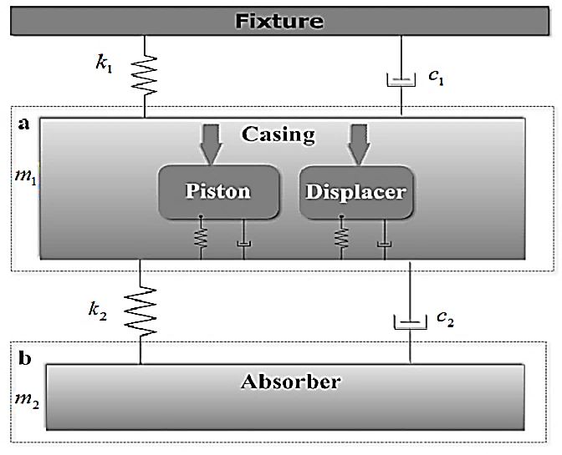

Figure 1 Dynamic model of the β-type Stirling engine showing a casing

The subsystem (a) of Figure 1 represents the casing of the Stirling engine which forms the main system that contains a displacer and a piston modeled as spring-mass-damper system. Subsystem (b) represents that of the TMD. The piston and the displacer move apporximately ${90}^{0}$ out of phase. When the gas inside the engine is heated, the displacer moves it from the hot end to the cool end creating a pressure wave on the piston. Since the piston motion causes the vibration of the engine case at 50Hz and the mass of the displacer is neglected compared to the piston plus the engine case mass, the internal dynamics between the piston and displacer are deemed unnecessary. By neglecting the internal dynamics of the piston and the displacer and by assuming that the piston movement is causing a sinusoidal excitation in the casing, a vibration model of the Stirling engine system is proposed by approximating it as a 2-DOF system. The mass $m_{1 }$ of the engine case $m_{1}$ is connected by a spring of stiffness $k_{1}$ and a damping mounts of coefficient $c_{1}$ to a fixed ground on one end and to a passive absorber of dynamic mass $m_{2 }$ via another spring of stiffness ${ k}_{2}$ and another damping element of coefficient $c_{2}$ on the other end. The dynamic mass $m_{2 }$ represents that actual solid mass of the absorber as well as a 3rd of the mass of the springs that connect the engine with the absorber. The equations of motion that describe the 2-DoF system can be represented in the form of a state-space model as follows

|  |  |  |
| --- | --- | --- |
| $$\begin{matrix}\dot{x}=Ax+Bu \\ y=Cx+Du\end{matrix}$$ $$\begin{matrix}\begin{matrix}\left[\begin{matrix}\begin{matrix}\dot{x_{1}} \\ \dot{x_{2}}\end{matrix} \\ \dot{x_{3}} \\ \dot{x_{4}}\end{matrix}\right]=\left[\begin{matrix}\begin{matrix}0 \\ 0\end{matrix} & \begin{matrix}0 \\ 0\end{matrix} & \begin{matrix}\begin{matrix}1 & 0\end{matrix} \\ \begin{matrix}0 & 1\end{matrix}\end{matrix} \\ \frac{{-(k}_{1}+k_{2})}{m_{1}} & \frac{k_{2}}{m_{1}} & \begin{matrix}\frac{{-(c}_{1}+c_{2})}{m_{1}} & \frac{c_{2}}{m_{1}}\end{matrix} \\ \frac{k_{2}}{m_{2}} & \frac{-k_{2}}{m_{2}} & \begin{matrix}\frac{c_{2}}{m_{2}} & \frac{-c_{2}}{m_{2}}\end{matrix}\end{matrix}\right]\left[\begin{matrix}\begin{matrix}x_{1} \\ x_{2}\end{matrix} \\ x_{3} \\ x_{4}\end{matrix}\right]+\left[\begin{matrix}0 \\ \begin{matrix}0 \\ \frac{1}{m_{1}} \\ 0\end{matrix}\end{matrix}\right]F\left(t\right) \\ \left[\begin{matrix}\begin{matrix}y_{1} \\ y_{2}\end{matrix} \\ y_{3} \\ y_{4}\end{matrix}\right]=\left[\begin{matrix}1 & 0 & \begin{matrix}0 & 0\end{matrix} \\ 0 & 1 & \begin{matrix}0 & 0\end{matrix} \\ \begin{matrix}0 \\ 0\end{matrix} & \begin{matrix}0 \\ 0\end{matrix} & \begin{matrix}\begin{matrix}1 \\ 0\end{matrix} & \begin{matrix}0 \\ 1\end{matrix}\end{matrix}\end{matrix}\right]\left[\begin{matrix}\begin{matrix}x_{1} \\ x_{2}\end{matrix} \\ x_{3} \\ x_{4}\end{matrix}\right]+\left[\begin{matrix}0 \\ \begin{matrix}0 \\ 0 \\ 0\end{matrix}\end{matrix}\right]F\left(t\right)\end{matrix}\end{matrix}$$ |  | (1) |

The state variable $x_{1}$ represents the engine case displacement, ${ x}_{2}$ the absorber mass displacement, ${ x}_{3}$ the engine case velocity and $x_{4}$ the $x_{1, }x_{2, }x_{3, }{and x}_{4}$ absorber velocity.

## Simulation

Table 1 contains the engine dynamic information based on engineering data provided by the manufacturer, Microgen Engine Corporation (MEC). The value of $c_{2}$ is assumed to be zero in the simulation and is identified later in the validation section. In the normal operation of this engine, it is assumed that sinusoidal excitation force $F(t)$ of magnitude $1000N$ and frequency $50Hz$ acts on the engine case. The passive TMD is tuned to minimize the vibration of the main mass at the nominal excitation frequency.

Table 1 Simulation Parameters

|  |
| --- |
| $$\begin{matrix}m_{1}=41.38 [kg] & c_{1}=200 [Ns/m] & k_{1}=8369.4 [N/m]\end{matrix}$$ |
| $$\begin{matrix}m_{2}=8.862 [kg] & c_{2}=0 [Ns/m] & { k}_{2}=874640 [N/m\end{matrix}]$$ |



Figure 2 Frequency response from excitation force to the engine case displacement (a) and to absorber mass displacement (b)

Figure 2 shows the frequency response from the engine case displacement (a) and absorber mass displacement (b) to the excitation force. The curves of Figure 2 (a) show two peaks values at 2Hz and 54.8Hz corresponding to the natural resonance of the composite system. The anti-resonance at 50Hz is associated with the operation of the TMD that is tuned to resonate naturally at 50Hz excitation that is sourced by the engine inherently. By examining the phase plot of the absorber mass in Figure 2 (b), both masses are in phase with the excitation force up to 2 Hz. After the first resonance, both of the masses switch to ${180}^{0}$ out of phase with respect to the excitation force. At 50Hz, the engine case switches back to $0^{0}$ phase in this case ($c_{2}=0 Ns/m$) and the absorber mass continues at ${180}^{0}$ out of phase with respect to the excitation force. As a result, at the nominal operation of the engine (50Hz), the absorber will be ${180}^{0 }$ out of phase with respect to the engine case, thus counteracting its vibration. The second resonance of the combined system occurs at 54.8 Hz where the engine case switches phase to become ${180}^{0 }$ with respect to the absorber.

## Model Validation

For the absorber, an electromagnetic shaker is used to shake the absorber and the data were recorded using acceleration sensors. For the engine, acceleration data of the engine were collected from a test performed at the company site.

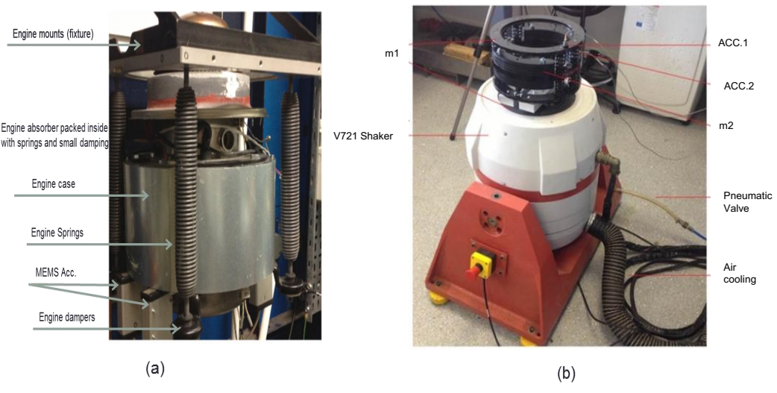

Figure 3 β-type Stirling engine, courtesy of Microgen Engine Corporation (MEC) and (b) Rig of the TMD

Test 1 setup for the engine model validation is shown in Figure 3 (a). The engine case $m_{1}$ is fixed to the wall via four springs and four rubber dampers that correspond to stiffness ${ k}_{1}$ and damping coefficient $c_{1}$. The absorber is mounted internally to the engine with dynamic mass that correspond to ${ m}_{2}$. The absorber features an additional mass comprising the holding rings and part of the springs that contribute to the mass ${ m}_{1}$. An inverter is used to excite the engine with a sinusoidal excitation and varying frequency between 49-51 Hz. Vibration Data were collected and averaged from four MEMS accelerometers with dynamic range ±2g, bandwidth 1 kHz and sensitivity of 350mv/g placed in four different locations to detect the vertical vibration.



Figure 4 Theoretical simulation and experimental validation of the engine

Figure 4 shows the experimental measurement of the engine case acceleration against the theoretical frequency response from excitation force to engine case acceleration described in system of equations (1). It reveals that the engine case acceleration is attenuated at 50Hz due to the resonance of the TMD. After 50Hz the amplitudes of the acceleration grow larger due to the second resonance of the combined system. There appears to be a difference between both sets of data as the experimental acceleration grows larger than the theoretical one after 50Hz. The cause of this difference is attributed to the excitation force amplitude which is assumed to be around 1000N in theory however in reality the magnitude of this force varies depending on frequency and loading of the engine.

Test 2 setup for the TMD is shown in Figure 3 (b). In this test, the absorber was separated from the engine and then mounted vertically on an electrodynamic shaker V721 series from Bruel & Kjaer. The shaker is controlled with an LDS USB vibration controller. Acceleration data from the dynamic mass of the absorber and the shaker table were collected from two accelerometers of 100 mv/g sensitivity and 70g max dynamic range interfaced with the 24-bit input stage of the controller. This test was performed using a sinusoidal profile between 40Hz to 80Hz in open loop. Generally a closed loop test is used to maintain a reference position, speed or acceleration of the shaker table. In this case, an open loop is used because the vibration of the shake table will be damped by the absorber at its tuning frequency. Originally the absorber is designed with minimal damping however a small amount of frictional damping is expected due the existence of internal guiding rods. Since the value of the damping coefficient of the absorber mass is not known beforehand, a reverse fitting technique is used to align the theoretical simulation results of the absorber model with the real test results obtained in this experiment.

The idea is to measure the acceleration of both the absorber dynamic mass and shaker table then plot the transmissibility from the shaker to the absorber. The theoretical transmissibility is expressed in the following equation in accordance with the test layout

|  |  |  |
| --- | --- | --- |
| $$TR(s)=\frac{{\ddot{X}(s)}_{absorber}}{{\ddot{X}(s)}_{shakertable}}=\frac{s^{2}{X(s)}_{absorber}}{s^{2}{X(s)}_{shakertable}}=\frac{c_{2}s+k_{2}}{m_{2}s^{2}+c_{2}s+k_{2}}$$ |  | (2) |

The test results are plotted against the simulation results in Figure 5. The theoretical results are reverse fitted by changing the value of $c_{2}$ accordingly. The results reveal a great match between the theoretical model and the experimental validation within the required operating range.



Figure 5 Theoretical and Experimental transmissibility response from the absorber to engine case ($c_{2}$ =2.7 Ns/m)

In Figure 5, the real response of the absorber shows some dynamics around 63 Hz which didn’t exist in simulation. The root cause of this discrepancy is linked to the second resonance of the combined system consisting of shaker table mass and the absorber mass which was not part of the simulated model. The value of damping in the absorber system is determined as ${ c}_{2}=2.7 Nm/s$. Having a validated model of the system, the following discusses the control law for mitigating the vibration within the Stirling engine based on the proposed model.

# Gain Scheduling with Zero-Placement Feedback Control

In this technique, the actuator control force is achieved based on two sets of information, the first feature requires a prior knowledge of the excitation frequency fedthrough to the controller and the second information is the measured response of the system.

The following figure provides an overview of the concept of operation in this control strategy

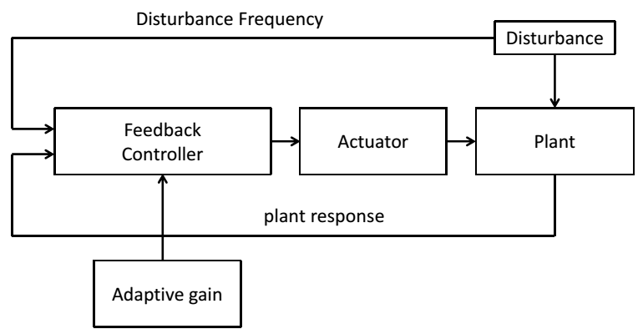

Figure 6 Operation principle of the proposed control strategy

## Relative and Absolute Measurement Feedback Analysis

The working principle of this control strategy is based on re-tuning of the ATMD so its natural resonant frequency tracks that of the excitation one.

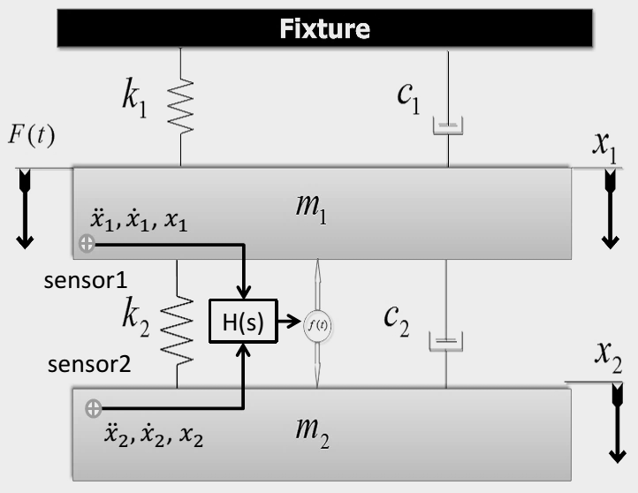

Figure 7 ATMD with a 2-DOF system

The equations of motion of the system in Figure 7 with the insertion of the actuator force $f(t)$ is derived as follows

|  |  |  |
| --- | --- | --- |
| $$\begin{matrix}m_{1}{\ddot{x}}_{1}+k_{1}x_{1}+c_{1}\dot{x_{1}}+k_{2}\left(x_{1}-x_{2}\right)+c_{2}\left({\dot{x}}_{1}-{\dot{x}}_{2}\right)=F(t)-f(t) \\ m_{2}{\ddot{x}}_{2}+k_{2}\left(x_{2}-x_{1}\right)+c_{2}\left({\dot{x}}_{2}-{\dot{x}}_{1}\right)=f(t)\end{matrix}$$ |  | (3) |

Assuming that a set of sensors is available to provide data about the response of the system, the actuator may then provide a force that is proportional to the product between a set of gains and the sensor information. Therefore, the actuator force $f(t)$ may take the following generic form depending on whether the measurement is relative or absolute [24]

|  |  |  |
| --- | --- | --- |
| $$f\left(t\right)=\left[α\left({\ddot{x}}_{1}-{\ddot{x}}_{2}\right)+β\left({\dot{x}}_{1}-{\dot{x}}_{2}\right)+γ\left(x_{1}-x_{2}\right)\right]$$ $$f\left(t\right)=-\left[α{\ddot{x}}_{2}+β{\dot{x}}_{2}+γx_{2}\right]$$ |  | (4) |

The gains α, β, and γ represent the acceleration, velocity and displacement feedback gains respectively. Equation 5 represents the Laplace domain closed loop transfer function that relates the primary mass displacement to the excitation force. It was found that the numerator of $W\left(s\right)$ remains unchanged regardless of the type of feedback measurement.

|  |  |  |  |  |
| --- | --- | --- | --- | --- |
| $$W\left(s\right)=\frac{X_{1}(s)}{F(s)}=\frac{\left(m_{2}+α\right)s^{2}+\left(c_{2}+β\right)s+{(k}_{2}+γ)}{a_{4}s^{4}+a_{3}s^{3}+a_{2}s^{2}+a_{1}s+a_{0}}$$ | |  | (5) | |
| Relative Measurement | Absolute Measurement | | |
| $${a_{4}=m}_{2}α+m_{1}\left(m_{2}+α\right) \\ a_{3}={(m}_{1}+m_{2})\left(c_{2}+β\right)+c_{1}(m_{2}+α) \\ a_{2}=k_{1}\left(m_{2}+α\right)+c_{1}\left(c_{2}+β\right)+{(k}_{2}+γ){(m}_{1}+m_{2}) \\ a_{1}={c_{1}(k}_{2}+γ)+k_{1}\left(c_{2}+β\right) \\ a_{0}=k_{1}{(k}_{2}+γ)$$ | $${a_{4}=m}_{1}α+m_{1}m_{2}$$ $a_{3}=c_{2}{(m}_{1}+m_{2})+c_{1}(m_{2}+α)$ + $βm_{1}$ $$a_{2}=k_{1}\left(m_{2}+α\right)+c_{1}\left(c_{2}+β\right)+k_{2}{(m}_{1}+m_{2})+γm_{1} \\ a_{1}={c_{1}(k}_{2}+γ)+k_{1}\left(c_{2}+β\right) \\ a_{0}=k_{1}{(k}_{2}+γ)$$ | | |

From Equation 5, the gains $α$, $β$, and $γ$ can be seen as mass, damping, and stiffness variations. Assuming that the absorber system has no damping $\left(c_{2}=0\right), W\left(s\right)$ possesses a zero equal to $\sqrt{-\frac{k_{2}+γ}{m_{2}+α}}$. Thus, it is possible to cancel the harmonic vibration $x_{1}$ of the mass $m_{1}$ by proper choice of the acceleration or displacement feedback gains. If the absorber inherently has some damping, the damping coefficient term will appear in the numerator of $W\left(s\right)$. The original zero of $W\left(s\right)$ will be the same if the feedback gain $β$ is chosen to cancel the damping ($c_{2}+β=0)$.

The other observation that can be made is that the zero of $W\left(s\right)$ is frequency of the absorber. Based on the previous analysis, it can be generalized that for the above system, a feedback force that is proportional to the relative displacement or acceleration of the two masses can alter the natural frequency of the absorber. If feedback force is proportional to relative velocity, it cannot alter the tuned frequency of the absorber but only the quality factor. The formulae that relate the required gain γ and α to produce a frequency shift to the absorber frequency $(ω_{2})$ so it tracks the excitation one $ω$ are shown in Equation 6

|  |  |  |
| --- | --- | --- |
| $$γ=m_{2}{(ω}^{2}-{ω_{2}}^{2}) α=m_{2}(\frac{{ω_{2}}^{2}}{ω^{2}}-1)$$ |  | (6) |

For the stability of $W(s)$ to be guaranteed, the following conditions are obtained following the Hurwitz Routh criterion [25] :

|  |  |  |
| --- | --- | --- |
| $$\begin{matrix}α>-m_{2} \\ β>-c_{2} \\ γ>-k_{2}\end{matrix}$$ |  |  |

## Control Simulation with Stirling Engine Parameters

In the model presented in Figure 8, the composite Engine and TMD system is represented in a state-space form. The excitation force magnitude is chosen as 1000 N with frequency varied from 46Hz to 56Hz in steps of 2Hz. The excitation frequency is calculated based by counting the number of zero crossings from the excitation source. In practice, the excitation frequency is measured directly from the grid when the engine is synchronized. In the case of the Stirling engine, the frequency measurement is performed by the engine control unit with the aid of a zero-crossing detector. It has to be noted that variations in grid frequency are relatively slow.

The aim of this simulation is analyze the effect of the control action with position and velocity feedback control as presented earlier. The frequency response from the excitation force to the engine case displacement is shown and analyzed. The scheduling of gain $γ$ is determined automatically as presented in equation 6. In here, since the absorber is assumed to possess an inherent damping of coefficient $c_{2}$ =2.7 Ns/m, a velocity feedback is used to remove this damping in order to ensure maximum attenuation of the engine case vibration.



Figure 8 SIMULINK model used to simulate the control of the engine vibration with ATMD

The graphs of Figure 9 show the frequency response of the engine case displacement. As the excitation frequency is varied, the control automatically determines a gain online that alters the TMD’s natural frequency to track the excitation frequency. This control technique doesn’t only attenuate the vibration of the system at a particular frequency, but it also shifts the resonant frequency of the composite system. That is, the vibration can be attenuated even when the excitation matches the original resonance of the composite system.



Figure 9 Frequency response from excitation force to engine case displacement with position and velocity feedback

# Test Rig Setup

For the purpose of implementing the control law, a lab test rig emulating the behavior of the Stirling engine alongside its proposed vibration model is designed and built as shown in Figure 10. The test rig is built in such a way that the mass ratio of the absorber to the shaker table is similar to that of the Stirling engine $μ=\frac{m_{2}}{m_{1}}=0.21$. An electrodynamic shaker (V406) from B&K is mounted vertically as shown. The shaker acts as the source of periodic excitation to the 2-DOF system which features a shaker table whose vibration to be cancelled by means of an ATMD system which is passively tuned at 50Hz. The ATMD consists of a planar spring attached on the top of the moving shaker table. A Voice Coil Motor (VCM) is set to provide the actuation for active damping and is mounted between the shaker table and the dynamic mass of the ATMD.

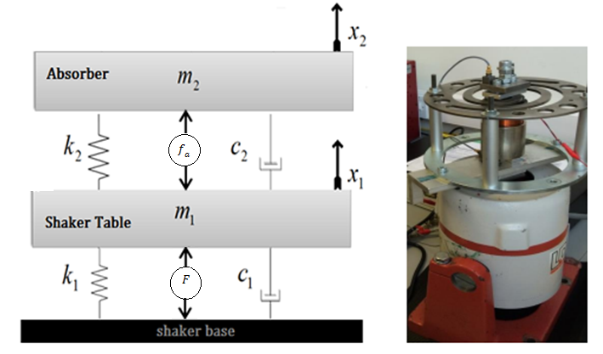

Figure 10 Test rig and the corresponding vibration model

## Model of the test rig

An electromechanical model is developed to represent the shaker rig mathematically for the purpose of performing theoretical studies and determination of important parameters such as the VCM damping. The VCM is modelled as an RL circuit with $V_{a}$ and $i_{a}$ representing the voltage across and the current through the VCM terminals. The terms $R_{a},$ $L_{a},$ and $k_{a}$ represent the motor coil inductance, resistance, and the motor constant respectively. The mass $m_{1}$ is the shaker table mass plus the VCM stationary base and the absorber stationary mass. The mass $m_{2}$ comprises the dynamic mass of the absorber and the VCM moving coil. Here it is assumed that the value of the back EMF constant is the same as $k_{a}$. At this stage, the damping introduced by the VCM is unknown and will be determined following the model validation of the test rig. The control force $f$ is proportional to the VCM motor current $i_{a}$ by $k_{a}$. A proportional controller is used to control the VCM current $i_{a}$ by comparing it to a desired reference current ${ i}_{r }$ generated by the control law. The excitation force $F$ is generated by the dynamic shaker and is also modelled as a VCM represented with subscript s. The resulting equations of the coupled electromechanical system are shown below

|  |  |  |
| --- | --- | --- |
| $$\left\{\begin{matrix}m_{1}{\ddot{x}}_{1}+k_{1}x_{1}+c_{1}\dot{x_{1}}+k_{2}\left(x_{1}-x_{2}\right)+c_{2}\left(\dot{x_{1}}-\dot{x_{2}}\right)=F-f_{a} \\ \begin{matrix}m_{2}{\ddot{x}}_{2}+k_{2}\left(x_{2}-x_{1}\right)+c_{2}\left(\dot{x_{2}}-\dot{x_{1}}\right)=f_{a} \\ \begin{matrix}V_{a}=R_{a}i_{a}+L_{a}\frac{d{\dot{i}}_{a}}{dt}+k_{a}\left({\dot{x}}_{1}-{\dot{x}}_{2}\right) \\ \begin{matrix}\begin{matrix}\begin{matrix}V_{s}=R_{s}i_{s}+L_{s}\frac{d{\dot{i}}_{s}}{dt}-k_{s}{\dot{x}}_{1} \\ F=k_{s}i_{s} \\ f_{a}=β\left({\dot{x}}_{1}-{\dot{x}}_{2}\right)+γ\left(x_{1}-x_{2}\right) \\ i_{r }=f_{a}/k_{a}\end{matrix} \\ \begin{matrix}\begin{matrix}\begin{matrix}V_{a}=k_{p}(\end{matrix}\end{matrix}\end{matrix}i_{r }-i_{a})\end{matrix}\end{matrix}\end{matrix}\end{matrix}\end{matrix}\right.$$ |  | (7) |

Where $γ$ and $β$ are relative positon and relative velocity feedback gains for the feedforward zero placement control technique and given by $γ=4π^{2}{ m}_{2}{(f_{exc}}^{2}-{f_{0}}^{2})$ and $β=-c_{2}$. $f_{exc}$ is the excitation frequency and $f_{0}$ is the resonant frequency of the absorber.

## Absorber Parameters

The exact values of the dynamic mass and the spring stiffness of the helical absorber are not available. The only available knowledge is that the natural resonance of the bare helical spring is around 104Hz and the damping is negligible. In here, we present a heuristic procedure to evaluate the spring stiffness and dynamic mass based on an experimental set of tests using the shaker rig. Assuming that the absorber behaves as a single degree of freedom system (SDOF), the idea is to use the shaker rig to vibrate the absorber system with a frequency sweep from 5Hz to 150Hz several times while adding a known mass for each sweep. By measuring the transmissibility of the absorber to the shaker table, the tuned frequency, $ω_{n},$ of the absorber is denoted. The natural frequency of the absorber changes according to ${ω_{n}}^{2}=k/(m+m_{n})$ where $k$ and $m$ are the unknown stiffness and dynamic mass respectively. The mass $m_{n}$ represents a known added mass. The equation can then be transposed to show that $k={ω_{n}}^{2}(m+m_{n})$ and $m=\frac{k}{{ω_{n}}^{2}}-m_{n}$. The idea is to find the values of $k$ and $m$ for a set of added mass $m_{n}$ and the associated frequencies $ω_{n}$ in such a way that that would minimize a function $Z$ shown in Equation 8. Matlab function “fminsearch” is used to find the minimum of Z starting with initial estimates of $m$ and $k$. This is generally referred to as unconstrained nonlinear optimization.

|  |  |  |
| --- | --- | --- |
| $$Z=\sum_{i=0}^{N-1}{\sum_{j=i+1}^{N}{\left[{\left[{ω_{i}}^{2}\left(m+m_{i}\right)-{ω_{j}}^{2}\left(m+m_{j}\right)\right]}^{2}+{\left[\left(\frac{k}{{ω_{i}}^{2}}-m_{i}\right)-\left(\frac{k}{{ω_{j}}^{2}}-m_{j}\right)\right]}^{2}\right]}}$$ |  | (8) |

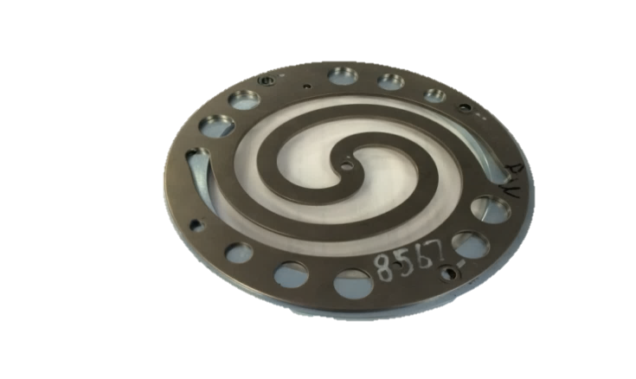

Figure 11 Helical Spring

Each run of the shaker involves adding a known mass to the dynamic mass of the helical spring then the frequency at which the maximum transmissibility occurs is measured. The chart of Figure 12 shows the measured frequencies for the added masses at which maximum transmissibility occurs.

Figure 12 Test results

Based on the optimization problem, the values of the stiffness and mass were determined as $k=40714 N/m$ and $m=0.0946 kg$. It follows that the dynamic mass for the absorber to be tuned at 50Hz is calculated following this equation ${ m}_{n}=\frac{k}{{ω_{n}}^{2}}$ which yields $m_{n}=0.4125 kg$. Thus the mass to be added to the absorber is $m=0.3179kg$. The obtained absorber parameters are used in the next section.

## Test Rig Model Simulation and Validation

This section is dedicated to the validation of the proposed model of the test rig in system of equations (7) in the frequency domain. The idea is to compare the test rig model simulation results with the experimental test. The benefit of this test is not only validating the proposed model, but also obtaining the damping introduced by the VCM. The VCM is a GVCM-051-051-01 motor purchased from Moticont. It is fitted with a linear bearing to ensure concentric alignment of its moving coil. In the test, the shaker is powered up using a power amplifier (PA500L) and controlled with a shaker controller (Laser Dactron USB) from Bruel & Kjaer using a sinusoidal excitation with variable frequency between 5Hz and 100Hz in open loop and open-circuited VCM. The values in Table 2 are adopted for the model simulation and test parameters of the rig.

Table 2 Model simulation parameters

|  |  |  |  |  |  |
| --- | --- | --- | --- | --- | --- |
| $$m_{1}$$ | 1.96 | [kg] | $$V_{s}$$ | 3sin(2π $f_{exc}$*t*) | [V] |
| $$m_{2}$$ | **0.4125** | **[kg]** | $$L_{s}$$ | **1.8** | **[mH]** |
| $$c_{1}$$ | **1** | **[Ns/m]** | $$R_{s}$$ | **1.2** | **[Ω]** |
| $$c_{2}$$ | **7** | **[Ns/m]** | $$k_{s}$$ | **11.1** | **[N/A]** |
| $$k_{1}$$ | **12300** | **[N/m]** | $$L_{a}$$ | **1.3** | **[mH]** |
| $$k_{2}$$ | **40714** | **[N/m]** | $$R_{a}$$ | **2.7** | **[Ω]** |
| $$f$$ | **5-100** | **[Hz]** | $$k_{a}$$ | **8** | **[N/A]** |

The measurement signals are interfaced to the shaker controller system via its 24-bit analogue input stage. Acceleration data were collected from both the absorber and shaker table with the aid of two accelerometers of 100 mv/g sensitivity and 70g max dynamic range. The electrical current consumed by the shaker is measured using a low noise non-contact current of dynamic range $±20A$ and $0.01 A$ resolution. The force exerted by the shaker table is determined by taking the product of the electrical current and shaker motor constant $k_{s}$. The results from both the simulation and experiments are depicted in the graphs of Figure 13. The results reveal a very close match between the theoretical model predictions and the experimental results. Figure 13 (a) shows the curves of the shaker table displacement with two peaks corresponding to the resonant frequencies of the composite at 10Hz and 55Hz. At 50Hz, the shaker displacement is attenuated to minimum due to the effect of the absorber that is tuned at 50Hz. The absorber displacement is show in Figure 13 (b). The transmissibility plot is shown in (c) and reveals that at 50Hz, the shaker force is completely transmitted from the shaker table to the absorber mass. Figure 13 (d) shows the force exerted by the shaker. The experimental results revealed the VCM introduces further damping into the ATMD system mainly due to hysteresis and eddy current losses. Although there exists a small viscous damping (proportional to speed) due to the linear bearing friction, this could be neglected when compared to eddy current losses at the operating speeds of this applications. Furthermore, the ATMD in this test is originally tuned at one frequency (50Hz) and the VCM was open-circuited across its terminals, the results showed that the extra damping is not related to the current flowing through the VCM coil (as there is an open circuit placed across its terminals). It is mainly due to the eddy currents generated in the VCM structure. It follows that the value of the damping is determined $c_{2}=7 Ns/m$ by reverse fitting the theoretical results onto the experimental ones.



Figure 13 Theoretical model results vs experimental results. The value of damping coefficient is determined $c_{2}=7 NS/m$

## Test Rig Control Simulation

The plots of Figure 14 show the time domain simulation results of the verified model of the test rig that was presented in system of equations (7). The values in Table 2 are adopted for the model simulation. The simulation is performed for 60 seconds where the excitation frequency is varied from 45 Hz to 55 Hz every 5 seconds. It considered the cases of no control and gain scheduling control with both positon and acceleration feedback is considered. A velocity feedback is also used to remove the effect of the damping introduced by the VCM. The description of this simulation is similar to the schematic presented in Figure 8 where the model of the Stirling engine is now replaced with that of the test rig.

In Figure 14 and Figure 15 (a) and (b), when control is off, the ATMD only attenuates the vibration at its tuned frequency (50Hz) shown in gray. Theoretically the ATMD should cancel the vibration of the shaker table completely at 50 Hz when it has no damping, however in this case the vibration in the shaker table is not fully cancelled due to the existence damping in the VCM , nevertheless it is minimum at this frequency. After 50Hz, the magnitude of the shaker table vibration grows larger as the frequency of excitation shifts rightwards away from 50Hz to reach a maximum value at the combined resonance of the entire shaker-rig system occurs around 56Hz. With active control on, it is revealed that a far better performance is reached than with the passive case for all the frequencies between 45Hz and 55Hz with both position and acceleration feedback. The actuator force, stroke, voltage, current, and power consumption are also plotted. The predicted power consumption of the VCM decreases from a max value at 45Hz to a minimum at 50Hz then increases again with frequency.

The simulation results show that the proposed control law has succeeded in mitigating the vibration of the shaker table theoretically for the validated shaker rig model. In addition to that, the required voltage, current, and power of the VCM are extracted. This allows for proper choice of the implementation hardware. The following section considers the implementation of the ATMD in the real test rig.



Figure 14 Time domain simulation results for the active damping control with position and velocity feedback



Figure 15 Time domain simulation results for the active damping control with Acceleration and velocity feedback

# Implementation

This section is dedicated to the validation of the findings presented in the previous section. The shaker rig is now used to perform the control implementation of the proposed control strategies.

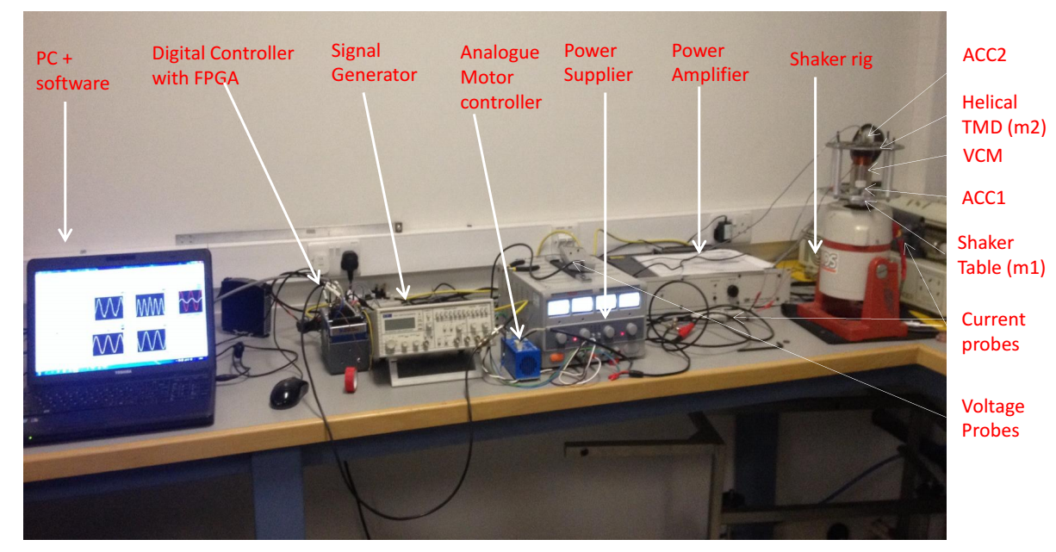  
Figure 16 Active damping shaker rig

In this experiment, the shaker is powered by a 1.3 KVA power amplifier which is controlled by a small voltage signal between ±2 volts. The VCM (GVCM-051-051-01) is powered with a servo linear drive amplifier TA105 capable of delivering a max current of 2A peak to peak controlled by a fast proportional current controller. The motor amplifier control signal is output by the control code as a reference current to be delivered by the VCM.

The control code is compiled on a CompactRio 9024 controller featuring an industrial 800 MHz real-time processor that runs LabVIEW for deterministic, reliable real-time applications used for control, logging, and data analysis. The controller also features a user-defined FPGA circuitry in its chassis that controls each I/O module. Two LabVIEW codes were implemented simultaneously on the CompactRio real time engine and the FPGA respectively. The acceleration measurement, processing, and control are performed on the FPGA with a 20µs execution loop rate. Data logging is performed on the real time code with a 100ms loop rate and communicates to the FPGA code via direct memory access FIFOs.

Two analogue input modules (NI 9234, NI 9205) and one analogue output module (NI 9263) were used to process the signals. The excitation frequency of the shaker table is measured using an analogue period measurement block provided in LabVIEW FPGA library. Acceleration data of the shaker table and the ATMD were obtained from two accelerometers with dynamic range of ±71g mounted in the middle of the shaker table and the helical spring respectively. The acceleration signals were sampled at a rate of 50KS/s using an AC coupled input stage of a 24-bit ADC. A 2nd order Butterworth low-pass filter with a variable cut-off frequency is employed to remove any measurement noise from the accelerometers. The velocity and position of the shaker table and ATMD are obtained by performing digital time integration twice. Two high-pass filters with 2.5Hz cut-off are used to eliminate any signal drift that may result from the time integration.

There is a drawback associated filtering the input signals concerning a resulting phase shift which may deter the control action or even destabilize it. In continuous-time systems, a low-pass filter induces a phase lag whereas a high-pass filter induces a phase lead depending on the cut-off frequency. It follows that a combination of a low pass and high pass filter can be optimized based on careful choice of the cut-off frequencies in such a way that produces zero phase shift. In the implementation code, a variable cut-off frequency of the low-pass filter is determined with adaptive filter coefficients following the formulae of $f_{Hp}$ and $f_{Lp}$ in Table 3. The following figure shows the schematic of the active control implementation.

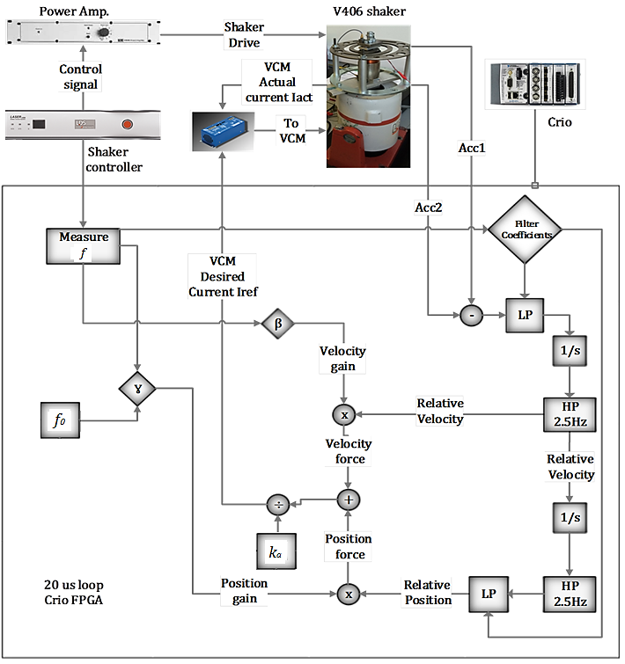

Figure 17 Schematic Diagram of the control model Testing and Validation of the Proposed Methods

Table 3 Test Parameters

|  |  |  |  |
| --- | --- | --- | --- |
| **Parameter** | **Symbol** | **Value** | **Unit** |
| **Shaker Excitation** | $$V_{s}$$ | $$4 \sin{2πf_{exc}T}$$ | **[V]** |
| **Excitation Frequency** | $$f_{exc}$$ | **40 - 60** | **[Hz]** |
| **Test time** | **T** | **60** | **[S]** |
| **FPGA loop rate** | **Ts** | **20e-6** | **[S]** |
| **ATMD resonance** | $$f_{ATMD}$$ | **50** | **[Hz]** |
| **Position feedback gain** | $$γ$$ | $4π^{2}m_{ATMD}({f_{exc}}^{2}-{f_{ATMD}}^{2}$**)** | $$[Ns^{2}/m]$$ |
| **Velocity feedback gain** | $$β$$ | **-7** | $$[Ns/m]$$ |
| **VCM reference current** | $$i_{ref}$$ | $$\left((γ\left({\ddot{x}}_{1}-{\ddot{x}}_{2}\right)+β(x_{1}-x_{2})\right)/k_{vcm}$$ | **[A]** |
| **Low-Pass cut-off** | $$f_{Lp}$$ | $${{f_{exc}}^{2}/f}_{HP}$$ | **[Hz]** |
| **High-Pass cut-off** | $$f_{Hp}$$ | **2.5** | **[Hz]** |

## Experimental Characterization of Damping Coefficient in the ATMD

In section 4.3, the damping introduced by the VCM is characterized for the case when the VCM was open-circuited and when the ATMD was tuned at 50 Hz. In this test, the VCM is closed-circuited and the ATMD tuning frequency changes to track that of the excitation. An original test with active damping control was carried out by running the test rig between 40Hz and 60Hz. The shaker table frequency is swept automatically from 45Hz to 55Hz in a time interval of 1 minute. In the implementation code, the active control is started automatically when the sweep reaches 45Hz then turned off after the sweep has reached 55Hz. Position and velocity feedback was used to generate the control signal to be delivered to the VCM. The position feedback gain was chosen based on the formula of γ presented in equation 6. The value of the damping coefficient in the ATMD was assumed to be constant $c_{2}=7 NS/m$ as validated in section 4.3. Hence, the velocity feedback gain was chosen to be ${β=-c}_{2}=-7 NS/m$ to reduce the effect of damping in the ATMD. The results of the test are displayed in Figure 18



Figure 18 Active damping control with position and velocity feedback with $β=-7 NS/m$

The results show that the ATMD does track the excitation frequency however it doesn’t attenuate the shaker table vibration to the required level. The investigation of this outcome reveals that the damping value of the ATMD is not chosen correctly. Further investigation indicates that the damping in the VCM is not constant and it changes with frequency. This warrants the characterization of the damping coefficient in the VCM for the operating frequency range (45Hz -55Hz).

A procedure of characterizing the damping of the ATMD using active damping of vibration control is followed. The rig was vibrated with a 3 volts sinusoidal excitation and frequency that is varied manually from 45Hz to 55Hz in steps of 0.5Hz with the shaker used in open loop configuration. The active control is switched on and the velocity feedback gain β is allowed to be changed manually. As the frequency is incremented, the value of velocity gain β was varied up or down until the minimum value of the shaker table acceleration is observed. The minimum acceleration is associated with the minimum damping that can be removed from the ATMD system. During the tuning of the velocity gain, it was observed the system becomes unstable after exceeding a critical beta value as per the stability condition suggests in section 3.1. It follows that the tuning of the β below is actually performed while allowing for slight damping in the system to ensure stability is guaranteed. Figure 19 illustrates the findings of the required velocity gain needed in order to remove damping from the ATMD system. The values of β are then used for the shaker rig ATMD with the implementation test.

Figure 19 Velocity gain against excitation frequency

It follows that velocity gain β has to be varied in the control code as per the following equation.

|  |  |  |
| --- | --- | --- |
| $$β=-(0.103{f_{exc}}^{2}-9.58f_{exc}+208)$$ |  | (9) |

## Active Control Test with Feedforward Control

In this test, the shaker excitation frequency is varied linearly from 40Hz to 60Hz in a time interval of 1 minute. The active vibration control is only operated in the frequency range between 45Hz and 55Hz. The ATMD is originally tuned at 50Hz and the active control aims to re-tune the ATMD frequency so it tracks that of the excitation. The velocity feedback gain β is determined adaptively following the formula provided in equation (9). The graphs of Figure 20 present the experimental test results of the shaker table acceleration with passive TMD and the actively controlled ATMD in the frequency and time domains for both cases with relative and absolute feedback measurements.



Figure 20 Active vibration control with position and velocity feedback with $β =-( 0.1031{f_{exc}}^{2} - 9.5766f_{exc} + 207.96)$

When originally tuned at 50Hz, the passive TMD only attenuates the shaker table vibration at 50Hz only whereas the ATMD attenuates the vibration of the shaker table very well when control is on between 45-55Hz. Outside the 45Hz-55 Hz interval, control is off where ATMD acts like a passive TMD with additional damping, hence the sudden difference at 45Hz and at 55Hz. Furthermore, by comparing the graphs of Figure 20 to those presented earlier in Figure 18, it is revealed the ATMD with adaptive velocity feedback gain achieves a better attenuation. It is revealed that the proposed active control with either relative or absolute measurement succeeds in attenuating the vibration of the shaker table mass across the entire range of frequency between 45Hz and 55Hz. As for the absolute measurement, similar response is achieved.

# Conclusion

In this work, an active vibration control strategy employing an ATMD with a linear voice coil actuator is proposed and tested experimentally for the mitigation of the vibration problem in the Stirling engine with the aid of a scaled test rig. A simple zero-placement control law utilizing both position and velocity feedback succeeded in mitigating the vibration of the test rig structure for a wide bandwidth between 45Hz and 55Hz compared to a passive system that only operative at 50Hz. The damping introduced by the VCM actuator was found to vary with frequency non-linearly and a novel procedure was followed for determining the damping coefficient in the ATMD used in the test rig. Furthermore, a novel experimental procedure benefiting from the test rig is used for evaluating the stiffness and dynamic mass of a spring mass system based on an optimization technique.

# Acknowledgment

We are very grateful to Microgen Engine Corporation (MEC) for providing the necessary engineering data required for modelling, simulation, and testing carried out in this work.

**References**

[1] J. Harrison, "Micro combined heat & power (CHP) for housing," in *3rd International Conference on Sustainable Energy Technologies, Nottingham, UK,* 2004, .

[2] ENTSO, "MEC Linear Free Piston Stirling Engine Generator Informal Technical Discussion with Helge Urdal National Grid," 2015.

[3] ENTSO, "ENTSO-E Draft Network Code for Requirements for Grid Connection applicable to all Generators," 2015.

[4] J. P. den Hartog, *Mechanical Vibrations.* Dover Publications, Incorporated, 1956.

[5] C. M. Harris and C. E. Crede, *Shock and Vibration Handbook.* McGraw-Hill, 1961.

[6] Y. Liu, T. P. Waters and M. J. Brennan, "A comparison of semi-active damping control strategies for vibration isolation of harmonic disturbances," *J. Sound Vibrat.,* vol. 280, pp. 21-39, 2/7, 2005.

[7] J. T. Yao, "Concept of structural control," *Journal of the Structural Division,* vol. 98, pp. 1567-1574, 1972.

[8] J. Morison and D. Karnopp, "Comparison of optimized active and passive vibration absorbers," in *Joint Automatic Control Conference, 14 Th, Columbus, Ohio,* 1973, pp. 932-938.

[9] J. C. Chang and T. T. Soong, "Structural control using active tuned mass dampers," *Journal of the Engineering Mechanics Division,* vol. 106, pp. 1091-1098, 1980.

[10] G. De Roeck, G. Degrande, G. Lombaert and G. Müller, "A versatile active mass damper for structural vibration control," 2011.

[11] Yi-De Chen, Chyun-Chau Fuh and Pi-Cheng Tung, "Application of voice coil motors in active dynamic vibration absorbers," *Magnetics, IEEE Transactions On,* vol. 41, pp. 1149-1154, 2005.

[12] K. Park, D. Choi, A. Ozer, S. Kim, Y. Lee and D. Joo, "A voice coil actuator driven active vibration isolation system with the consideration of flexible modes," *Rev. Sci. Instrum.,* vol. 79, pp. 065106, 2008.

[13] Y. Liu and W. Wu, "Active Vibration Isolation Using a Voice Coil Actuator with Absolute Velocity Feedback Control," *International Journal of Automation and Smart Technology,* vol. 3, pp. 221-226, 2013.

[14] B. Ross, "Status of the emerging technology of Stirling machines," *Aerospace and Electronic Systems Magazine, IEEE,* vol. 10, pp. 34-39, 1995.

[15] D. Berchowitz, "The development of a 1 kW electrical output free piston stirling engine alternator unit," in *Proc., Intersoc. Energy Convers. Eng. Conf.;(United States),* 1983, .

[16] C. Cheng and Y. Yu, "Numerical model for predicting thermodynamic cycle and thermal efficiency of a beta-type Stirling engine with rhombic-drive mechanism," *Renewable Energy,* vol. 35, pp. 2590-2601, 2010.

[17] J. S. Rauch, "Vibration absorber for a free piston Stirling engine," 08/30, 1983.

[18] S. Qiu, J. Augenblick, A. Peterson and M. White, "Active balance system and vibration balanced machine," Apr, 2005.

[19] E. S. Holliday, "Driving an active vibration balancer to minimize vibrations at the fundamental and harmonic frequencies," Aug, 2014.

[20] R. G. Ross Jr, "Vibration suppression of advanced space cryocoolers- An overview," *Smart Structures and Materials 2003,* vol. 5052, pp. 1-12, 2003.

[21] L. A. Sievers and A. H. von Flotow, "Comparison and extensions of control methods for narrow-band disturbance rejection," *Signal Processing, IEEE Transactions On,* vol. 40, pp. 2377-2391, 1992.

[22] W. Johnson, R. Long, M. Nelson and D. Mascarenas, "Embedded active vibration cancellation of a piston-driven cryocooler for nuclear spectroscopy applications," in Anonymous Springer New York, 2012, pp. 377-384.

[23] A. Hassan, A. Torres-Perez, S. Kaczmarczyk and P. Picton, "ACTIVE VIBRATION CONTROL FOR A FREE PISTON STIRLING ENGINE GENERATOR USING A VOICE COIL ACTUATOR," *MM (Modern Machinery) Science Journal,* pp. 547, 2015.

[24] R. F. Marques, D. A. Rade and S. S. Cunha Jr, "Assessment of an active dynamic vibration absorber," in *Proceedings of IMAC-XIX: A Conference on Structural Dynamics: February 5-8, 2001, Hyatt Orlando, Kissimmee, Florida,* 2001, pp. 32.

[25] K. Ogata, *Modern Control Engineering.* Prentice Hall, 2010.