Strategies for local authorities to achieve the EU 2020 50% recycling, reuse and composting target: a case study of England

Abstract

The revised Waste Framework Directive requires EU Member States to recycle 50% of their household waste by 2020. This study of 48 English authorities from five regions, between 2008/09 and 2012/13, analysed whether the national 50% target was likely to be achieved by 2020 and also investigated the main barriers and possible solutions for local authorities to attain 50% recycling.

This study identified that England is unlikely to meet the EU target to reuse, recycle and compost 50% of its household waste by 2020. Key issues included central Government support and guidance, and difference in collection systems by high and low rate local authorities.

Key recommendations including structural changes to the collection service including alternate weekly collection for dry recyclate and garden waste with a separate weekly collection of food waste, are suggested. Discussion on suggested amendments to the system of measurement are also included.

Key words: Recycling, Local authority, England, EU 50% target, Waste collection schemes

1. Introduction

The European Union (EU) Waste Framework Directive 2008/98/EC (rWFD) (EU, 2008), outlined an overarching framework of the basic principles and definitions governing the management of waste in Europe. Amongst other factors, it required EU member states to apply the EU Waste Hierarchy, as well as adhere to two recycling and recovery targets by 2020. The targets are: Article 11.2(a) required member states to reuse and recycle at least 50% of their household waste by 2020, and 70% preparing for re-use, recycling and other recovery of construction and demolition waste. Members failing to transpose a Directive properly can be liable to legal action by the European Commission (EC) (FEUD, 2008). The maximum fine that could be imposed is approximately £517,000 per day, equating to around £256 million per year (TSG, 2014). The EC allowed four methods of calculating the reuse and recycling rate (Hogg, 2014) and the United Kingdom (UK) chose the following method:

Recycling rate of household waste in % = Recycled amount of household waste/Total household waste amount excluding certain waste categories

The materials that could be utilised included paper and cardboard, metals, plastic and glass, biodegradable kitchen and canteen waste, biodegradable and non-biodegradable garden and park waste, wood, textiles and batteries (EU, 2008). With biodegradable material being allowed, the reuse and recycling rate also includes material that can be composted. Thus it will be referred to as the reuse, recycling and composting (RRC) rate.

To meet the requirements of the rWFD, the Department of Environment Food and Rural Affairs (Defra) transposed it via the Waste (England and Wales) Regulations 2011 (WR2011) which were subsequently amended in 2012 and 2014. England’s RRC rate had been steadily increasing since 2000/01, but slowed up to the end of 2012/13 at 43.2% (Defra, 2013a).

The main aim of this project was to investigate the major barriers facing English local authorities (LAs) trying to improve their RRC rates and to assess what factors might have contributed to ‘significant’ variations in the rate. Significance was determined by a positive (or negative in the case of waste arisings) annual tonnage change over a chosen percentage threshold, in a number of categories from 2008/09 to 2012/13.

2. The RRC rate in England

The UK needs to achieve a yearly average percentage point increase of approximately 1% between 2010 and 2020, to reach the 50% target (EEA, 2013). WRAP (2014a) predicted that England will need to recycle an additional 1.7 million tonnes before 2020 to meet the target. In 2012/13, only 73 out of 352 English authorities achieved a 50% RRC rate (Defra, 2013a). Across the rest of the UK, the RRC rates were Scotland: 41.2% (MRW, 2013), Northern Ireland: 39.7% (NIEA, 2013), and Wales: 52% (Welsh Government, 2014).

There have been conflicting views, including from Government, as to whether England would meet the target, with some saying yes (Defra, 2013b; EEA, 2013), and others no (Parliament, 2014a; Hogg, 2014; Resource, 2014). For example, Defra (2013b) argued that the most statistically and economically robust forecasting approach was the seasonal auto-regressive integrated moving average (SARIMA) method. This approach forecasted an average amount of 22.6 million tonnes of household arisings in 2020, a rate of 51%, therefore meeting the target. Alternatively, Hogg (2014) argued that the target would not be met as the legislation did not include statutory recycling targets or the ability to introduce ‘pay as you throw’ (PAYT). Similarly, Parliament (2014a) claimed that meeting the target would be difficult due to the removal of statutory targets and the reduction of LA’s budgets.

2.1 The role of central and local government
2.1.1 Central government

In 2013, Government stated that it would be stepping back from waste management areas where businesses were better placed to act and where there was no clear market failure (Defra, 2013c). However, the Environment, Food and Rural Affairs (Efra) Committee (Parliament, 2014) argued that England would not meet the 50% target unless there is clear leadership and renewed policy drivers from Defra. These drivers should include statutory recycling targets for LAs with the requisite funding support, improved householder engagement, Defra continuing to take a leading role, and the Minister responsible having responsibility across all Government departments. Beasley Associates et al. (2011) also concluded that there was an absence of targets and an over-reliance on voluntary agreements.

2.1.2 Local government
Defra (2007) introduced a waste strategy. This included a national indicator (NI 192) to measure the percentage of household waste arisings sent for reuse, recycling, composting or anaerobic digestion, and to be monitored by authorities in England and Wales. However, it was abolished in March 2011, thus reducing LA accountability for the RRC rate.

A key challenge to LAs came from the rWFD which required them to collect paper, metals, plastics and glass separately where doing so is ‘necessary’ and technically, economically and environmentally practicable (TEEP), from 1st January 2015 (EU, 2008; Defra, 2012).

Street sweepings to collect leaf litter for composting were previously included in the RRC rate calculation. However, following a trial in 2013 they were not allowed to be included in English and Welsh figures, due to contamination from toxic substances (EA, 2013). This change had an adverse impact on the RRC rate as the street sweepings total tonnage in 2012/13 was 1.15 million tonnes (WasteDataFlow, 2014).

2.2 Householder influencing factors
2.2.1 Socio-psychological constructs
The degree of ease of recycling is critical and is linked to the type and design of the collection scheme, the materials being recycled, convenience, time and the level of change of existing behaviours required (Perrin and Barton, 2001; Tonglet et al., 2004; Barr and Gilg, 2005; Defra, 2008). Householders also appreciate knowledge and feedback regarding the collection system (Martin et al., 2006; Timlett and Williams, 2008). Recycling is directly linked to householder attitudes (Tonglet et al., 2004) and over time, they can become habitual, although transience can cause them to decline (Timlett and Williams, 2009; Thomas and Sharp, 2013). Research in the UK illustrated different types of householder recyclers, ranging from ‘positive greens’, to ‘stalled starters’ (Defra, 2008a; WRAP, 2008).

2.2.2 Communications
For collection schemes to work effectively householders must understand what the scheme involves and what their obligations are. This can only be done with effective communications. The method of communication can vary (e.g. local or national campaigns, targeted to specific groups of householders or towards a specific element (e.g. waste prevention)) (WRAP, 2009).

Direct house to house publicity of LA opportunities can have a demonstrable positive effect (Robinson and Read, 2005). Mee et al. (2004) concluded that authorities should use standard communications to design campaigns and that this should be done with trained staff and not generalists.

2.2.3 Collection methods
A range of collection systems are required to meet the varying circumstances within which local authorities provide recycling services, and to maximise value recovery (WRAP, 2010; Shaw et al., 2006; Green Alliance, 2014).

Lane and Wagner (2013) argue that there is no single recycling container in terms of size, colour or type that can maximise householder participation or recycling rates. The choice depends on the unique characteristics of the collection area, balanced with costs. Abbott et al. (2011) found an inverse relationship between the frequency of the residual waste collection (particularly for organic waste) and the recycling rate.

Alternate weekly collection (AWC) is the most popular form of household waste collection in England (Parliament, 2013; Parfitt and Bridgewater, 2011). AWC allows residual waste destined for landfill or energy from waste (EfW) to be collected on one week and material for recycling collected the next. AWC of co-mingled dry recyclates can have a positive impact on recycling rates and reduce waste arisings.

There are three main methods of collecting dry recyclates for recycling from households. Multi-stream collections generally have a separate receptacle for paper/cardboard, plastic, metals and glass whilst twin-stream collections have separate receptacles for paper and cardboard (fibre), metals, plastics and glass. Co-mingled collections generally collect all of these materials in one container, which is then sent to a materials recovery facility (MRF) for mechanical and manual sorting (WRAP, 2010). There is no consensus regarding which dry recyclate collection system is the most cost effective, with debate for (WYG Environmental, 2012; 2013) and against co-mingled collections (WRAP Cymru, 2011; Williams and Cole, 2013).

Generally garden waste is collected separately, with the most popular method in England being in a 180 – 240 litre capacity wheeled bin. Where household food waste is collected, the most popular method is a 7 litre kitchen caddie which is then deposited into a sack or bin (e.g. a kerbside caddie or 180 – 240 litre wheeled bin) (WRAP, 2014b).

2.3.4 Urbanisation and socio-economics
Views on collection types and urbanisation vary. For example, Dahlen et al. (2009) noted that the amount of household waste was higher in urban areas and that no difference occurred in the weight of dry recyclates from householders when weight based charges were applied. However, Hage and Soderholm (2008) note that the distance to recycling facilities and the urbanisation rate or population density are statistically and economically insignificant.

2.4 Incentive schemes
The Climate Change Act (DECC, 2008) included provision for authorities to charge for the amount of residual waste put out. These charges could then be used as rebates to households that throw away the least waste (Defra, 2008b). However, this element of the legislation has been repealed (Hogg, 2014). The Environmental Protection Act 1990 prohibits schemes such as variable charging, direct regulation and reduced disposal charges through household incentives. However, all of these could be utilised in England with a change in legislation (Husaini et al., 2007; Dresner and Ekins, 2010).

Householders are intrinsically motivated to do the right thing without any form of incentive. Thus to change recycling performance requires a change to the service rather than introducing incentives (Shaw and Maynard, 2008; Eunomia, 2014). Serco (2014) argue that there is a lack of data regarding the long term impacts of household waste incentive schemes and cost more to operate than the delivered benefits.

3. Methods
As the RRC rate was based on weight actual tonnages were required. This information is published annually (Defra, 2014) for each of the nine English regions and all of their 352 individual local authorities. All of this information could not be analysed, therefore, it was necessary to select English regions and the appropriate local authorities within those regions. Greatest interest was in authorities that had exhibited a ‘significant’ positive RRC rate change and those that had a low RRC rate. They could then be contacted to either determine what caused the positive tonnage increase or what barriers existed to prevent an increase in their RRC rate.

3.1 Choosing the regions and their local authority criteria
The latest available data were for the period 2012/13, so it had to be determined what length of period to study up to that point. The annual increase in the national RRC rate dropped below 3% for the first time in 2008/09 and seemed to be the start of slowing RRC rate growth, therefore, a period of five years was chosen. The data showed that the Eastern, East Midlands and South West regions had the highest RRC rates in 2012/13, and that the North East and London had the lowest (Defra, 2014). The remaining four regions had very similar RRC rates although analysis of the gradient demonstrated that Yorkshire and Humber and the North West had the highest rates of growth up to 2012/13.

A choice also had to be made regarding which authorities to analyse, namely - all within a particular region, the highest and lowest performers or high and low authorities regardless of region. It was considered that simply choosing LAs regardless of region may have issues with comparable analysis of the region as a whole. Therefore, it was decided to initially choose the three regions with the highest RRC rates, namely; Eastern, East Midlands and South West followed by the two ‘high growth’ regions of Yorkshire and Humber, and North West. In addition to consider a number of the highest and lowest RRC rate local authorities within those regions. It should be noted that ‘high rate’ also included authorities that had a high rate of change and therefore these authorities may have had a low actual recycling rate in 2012/13. However, as this study was focused on particular authorities, there was a concern regarding how many of those initially selected would respond. Therefore, as a contingency, primary data were also obtained from low rate authorities in London and the North East as well as high rate authorities in the West Midlands and South East.

3.2 Selecting the local authorities

The following key tonnage information was obtained for each year of the study period for each authority in the selected regions (Defra, 2014):

- Household tonnage recycled, reused and composted
- Total household waste tonnage collected
- Household organic waste composted
- Household dry recyclate tonnage recycled and reused

In the chosen regions, 61 ‘high rate’ authorities were initially selected by taking those with the higher RRC rates as well as those that had shown high tonnages or a marked tonnage change in the categories above. To enable a similar number of ‘low rate’ authorities varying cut off RRC rate percentages were chosen up to 42%. This approach created 55 low rate authorities producing 116 sets of secondary LA data, as the basis to obtain further primary data.

For each chosen authority under consideration selected information could be produced (Table 1). Data were not available for household green waste or household dry recyclate in 2008/09 and 2009/10.

Table 1. Typical local authority tonnage data
Factor | Reporting period |  |  |  |  | % recycling
Factor | 08/09 | 09/10 | 10/11 | 11/12 | 12/13 | Rate 2012/13
Household tonnage: recycling, reuse and composting | 30,074 | 20,859 | 35,741 | 36,502 | 38,371 | 42
Total household waste tonnage collected | 106,618 | 104,068 | 106,812 | 98,979 | 90,302
Green waste tonnage composted |  |  | 18,594 | 15,809 | 15,283
Dry recyclate tonnage recycled and reused |  |  | 17,147 | 20,693 | 23,083

Even though high rate authorities had been initially selected it still had to be established whether any year on year changes had been meaningful. This precise timescale would help to suggest if a particular event caused the change. For all four categories a positive change was required although for total household tonnage collected a decrease in tonnage was the positive change required.

From Table 1, the percentage difference between each year for all four categories from each of the 116 local authorities was calculated. The percentage differences for each category were tabulated and a cut-off point determined that captured the authorities with the highest percentage differences. This resolved as a -5% change for total household waste collected and a +10% change for the other three categories. Conversely, a change of +5% and -10% for the same categories was seen as a negative change.

A typical result is shown in Table 2, where light grey highlights was a positive change and dark grey (15,809 tonnes in this case), a negative change. This reduced the 61 high rate local authorities down to 57 as four selected authorities had no positive change leaving 112 authorities available for further research.

Table 2. Typical local authority tonnage data with highlighted differences

Authority name | Reporting period |  |  |  |  | % recycling
Household tonnage: RRC | 08/09 | 09/10 | 10/11 | 11/12 | 12/13 | Rate 2012/13
Total household tonnage collected | 30,074 | 29,859 | 35,741 | 36,502 | 38,371 | 42
Green waste tonnage collected | 106,618 | 104,068 | 106,812 | 98,979 | 90,302 | 42
Dry recyclate tonnage recycled and reused |  |  | 18,594 | 15,809 | 15,288
 |  |  | 17,147 | 20,693 | 23,083

Information was utilised from WRAP (2014c) on the urban/rural classification on each of the 112 chosen local authorities. The classification has a scale of 1 to 6, where 1 equates to a major urban local authority and 6 to an authority comprising at least 80% rurality. Data were also obtained on the type of dry recyclate collection - multi-stream, twin stream or co-mingled and the organic waste collection to ascertain whether the garden waste collection was a charged service or not. Information was also gathered on the number of households covered by the collection scheme, the proportion utilising the organic waste collection and whether the LA was a unitary authority (undertaking both waste disposal and collection) or a WCA. Unitary authorities can also include non-household and household organic waste in their tonnage totals, whereas WCAs can only include household organic waste (WRAP, 2014c).

3.3 Questionnaires

A questionnaire was used to obtain primary data from the 112 selected LAs to ensure consistency between responses. It was personalised to the particular high rate authority by including their specific details, to increase response rates. It contained a mixture of fixed choice and open questions, and was in four main sections. In many instances it was not known which fixed choices to utilise, therefore, open questions were asked and the responses subsequently coded.

The first section sought basic information, including items collected for reuse, partnership working, communications and whether incentive schemes had been introduced. The second focussed on the barriers faced by low rate authorities to improve their RRC rate, and the barriers perceived by both authority types regarding the 50% national target. A third section examined awareness of the target and whether the Government should intervene to ensure it is met. The next section considered the initiatives that had been introduced to achieve positive tonnage changes. Assuming that the change had resulted from an authority’ initiative, a series of questions sought information on the actual change and the associated consequences. The final section concentrated on the three main recorded waste streams for recycling, reuse and composting, namely organic waste, co-mingled collections and paper, as well as whether the overall household waste collected had been decreasing. Co-mingled collections generally consist of paper/card, metals, plastic and glass although authorities report them as one tonnage total. These final questions sought to determine what might happen to these materials in the future in terms of a tonnage increase or decrease.

The questionnaire was the same for high and low rate authorities save for some minor differences. The low rate questionnaire: (1) was not populated with personalised tonnage data and did not include associated questions regarding the data, (2) included a specific additional question on the barriers faced in increasing their RRC rate and, (3) included a final question on whether they would consider implementing an initiative that had been proven in other authorities, to improve their RRC rate.

A pilot was undertaken with three LAs where the contact was already known, as well as with colleagues at WRAP. Local authority responses helped with some redundant questioning and the WRAP perspective highlighted that some information requests included data already held by WRAP and therefore could be removed.

Investigation of websites enabled contacts to be established for the 112 selected authorities. In order to obtain as high a response rate as possible, all 112 were telephoned beforehand to establish their willingness to participate. Follow up calls were made and an email requesting participation was sent to those who could not be contacted initially. A 56% response rate was achieved (Table 3).
Table 3. Responses across high and low rate authorities

Region | High Rate Local Authority | Low Rate Local Authority
Yorkshire & Humber | 5 | 2
North West | 3 | 8
East Midlands | 4 | 4
Eastern | 8 | 4
South West | 5 | 5
North East | 0 | 5
West Midlands | 3 | 0
London | 0 | 3
South East | 4 | 0
TOTAL | 32 | 31

Given that the response rate was above an initial requirement of 40% it was decided not to analyse information from the North East, West Midlands, London or the South East as this was contingency data only. This left 25 high rate questionnaire responses to be compared against 23 low rate ones across five regions.

3.4 Analysis

3.4.1 Local authority data
Using the existing household waste tonnage that arose and was recycled for 2011/12 and 2012/13 as datum points, separate trend analyses were undertaken for 2008/09, 2009/10 and 2010/11. This involved extending the tonnage of household waste collected and reused, recycled and composted to 2020 to assess the likelihood of the 50% target being met. These results were compared against published literature and commentary made regarding the likelihood of England meeting the target. This information was analysed to examine the underlying trends behind the RRC rate to help determine the factors leading to high and low rates.

3.4.2 Questionnaire data

First it had to be determined if the high rate responses were similar to the low rates. Second, if the data were normally distributed or not. Similarity would allow the regional information to be combined allowing direct comparison between the 25 combined high rate and the 23 combined low rate authorities.

Three key areas of urbanisation criteria (1-6), collection method (co-mingling, twin-stream and multi-stream) and household numbers were chosen to act as a test regarding whether the chosen (or observed) data were similar to the expected data. The expected data from each authority in all five regions were compared against the observed data from the selected authorities using Chi Squared tests. The null hypothesis was that the selected authorities were similar to all the authorities within the regions. The tests assumed that the frequency counts were similar if the probability (p value) was > 0.05 (5%) indicating that the deviation of the observed from the expected was due to chance alone.

For the null hypotheses to be accepted, both the high level and low level test results required skewness to be between –1.96 and +1.96 and the Shapiro Wilk criteria to be >0.05. The histograms should have an approximate bell curve and the box and whisper plots should be approximately symmetrical. Analysis showed that these criteria were never reached for any of the questions leaving the null hypotheses to be rejected. Therefore, the questionnaire results were not normally distributed and thus non-parametric statistical tests were applied.

Open responses were analysed and grouped into sections to allow themes to be identified. As the questionnaire data were predominantly nominal with some ordinal this also reinforced that non-parametric tests should be used.

4. Results

4.1 Similarity between high and low rate authorities
The 48 chosen local authorities were mainly composed of 38 WCAs, which is a similar ratio to authorities across England generally (Defra, 2013a; WRAP, 2014c). The urbanisation categories for the high and low rate authorities were similar to the expected frequency of the 182 authorities in the five chosen regions ( = 1.7, 5) and ( = 9.9, 5) respectively. The collection methods and the number of households were also similar ( = 6.2, 2). This confirmation of similarity allowed the null hypothesis to be accepted and the high and low rate authorities to be directly compared.

4.1.1 Urbanisation analysis
RRC rates are potentially influenced by the range of urban or rural location and thus there was coverage between high and low rate authorities within the six categories of urbanisation. There was also solid coverage of the three main dry recyclate collection methods against the six urbanisation categories, except for no data on co-mingled collection for the ‘significantly rural’ category. This was addressed by combining the rural categories 4, 5 and 6 into one ‘rural’ category where appropriate which also helped to overcome the only large difference of 7 high rate authorities against 2 low rate authorities in the 80% rural category.

There was similarity between both authority types ( = 6.2, 4). However, many of the individual counts were less than 5 and therefore this result should be treated with caution. Thus, it cannot be stated that urbanisation had no effect on the RRC rate, however, it was not a barrier to achieving high RRC rates as each of the six categories is represented in the RRC range from 48 - 67%.

4.1.2 Collection methods analysis
Both high and low rate authorities had the same number of twin stream collections with high rates preferring multi-stream collections and ‘low rate’ authorities favouring co-mingled collections. The method of dry recyclate collection had no effect on the RRC rate achieved (= 6.28, 2). However, it can be claimed that the collection method is not a barrier to achieving high RRC rates as each of the three collection methods was represented in the RRC range from 61 - 67%.

4.1.3 Results per household

By reordering the list of local authorities (Defra, 2014), using a per-household approach, each household in the highest ranked authority composted 0.59 tonnes on average. Eight authorities provided a charge for the collection of garden waste and two of these had an RRC rate above 50% indicating that charging the householder for garden waste collection was not a barrier to high RRC rates.

4.1.4 Comparison between reuse, recycling and composting
In 2012/13 the reuse, recycling and composting ratio for England was 0.07MT:9.6MT:3.9MT or 1:137:55 (Defra, 2014). Whilst reuse is extremely important, the tonnage utilised in 2012/13 was dramatically lower than that for the recycling of dry recyclate waste or the composting of organic waste. Despite recycling having the highest tonnage element in this ratio, it is broken down by individual material types mainly consisting of paper/card, metals, plastics and glass. Organic waste was the highest single tonnage element within the RRC rate.

4.2 Household collection tonnages
4.2.1 Household tonnage collected
The RRC rates were affected by the total household waste collected and the amount of material recycled, reused and composted. Secondary data for household waste collection secondary showed there was a comparable rate of decrease between both the high and low rate authorities from 2008/09 to 2012/13. High rate authorities had a more uniform rate of decrease (Figure 1). However, this is not a direct comparison as it is tonnage based and there were different authority numbers in each group.

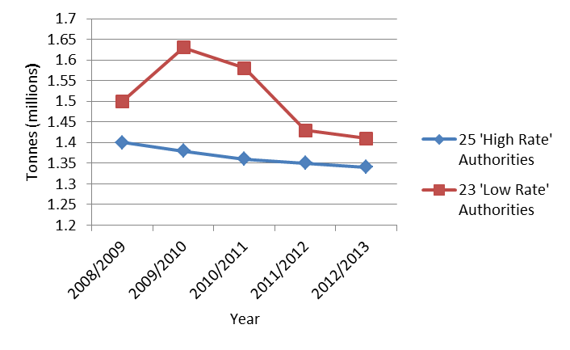

Figure 1. Total household tonnage collected

4.2.2 RRC rates
The high rate authorities in this study showed a steady RRC rate increase from 33% in 2008/09 to 48% in 2012/13. Similarly, the low rate authorities exhibited limited rate growth from 31% to 33% in the same period, despite the two groups having had similar rates in 2008/09 (Figure 2).

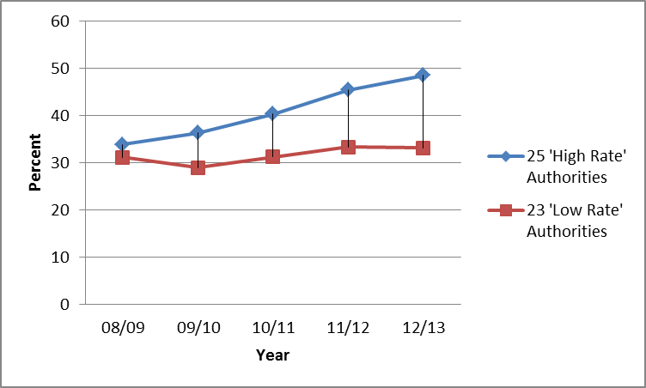
Figure 2. Recycling, reuse and composting percentages for 2008/9 – 2012/13

4.2.3 Dry recyclate collected
There is an evident difference in the chosen regions for dry recyclate collection as the high rate authorities lagged behind, however there is some indication of convergence in 2012/13. Also, it may be that low rate authorities composted less which would allow their dry recyclate percentage to be higher (Figure 3). There were no recorded dry recyclate tonnage figures until 2010/11.

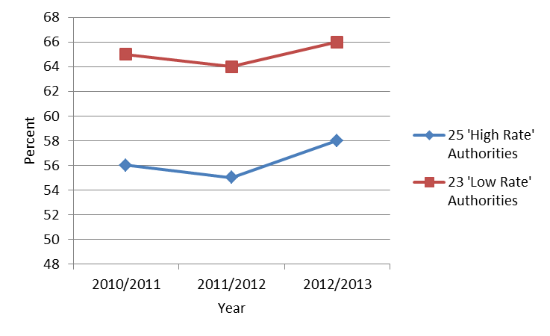

Figure 3. Percentage of dry recyclate recycled for 2010/11 – 2012/13

4.2.4 Organic waste collected
Despite the lack of data before 2010/11, the high rate authorities consistently showed a higher organic waste collection rate than low rates authorities (Figure 4). Due to the density of organic waste this percentage difference has more effect, in terms of RRC rate, than any difference in the dry recyclate collection rates.

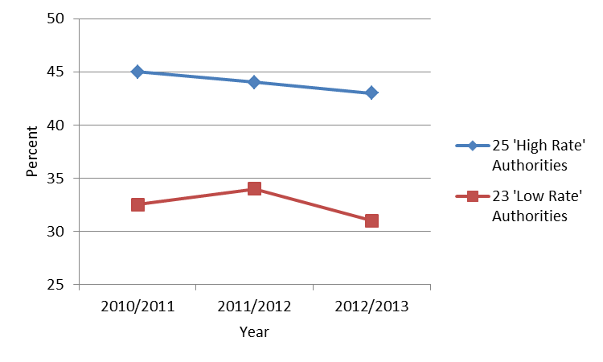

Figure 4. Percentage of organic waste composted for 2010/11 – 2012/13

In 2012/13, 96% of the high rate authorities had an organic waste collection of which 40% charged for garden waste, compared to 91% of the low rate households, with 22% charging. Yorkshire & Humber and North West region authorities had no organic collection charging. However, at least 50% of the high rate authorities in the other regions – Eastern, South West and East Midlands, charged, with the low rate authorities having at least 33% charging.

There was no similarity of charging between the high and low rate authorities (= 9.3, 1). Therefore, it cannot be stated that charging for garden waste collection had no effect on the RRC rate achieved, however, it can be claimed that charged garden waste collection is not a barrier to achieving an RRC rate of up to 61%.

4.2.5 Correlation of household collection tonnage
Low rate authorities collected more household waste in 2012/13, as they had higher numbers of households. The average amount collected from each high rate household was 0.853 tonnes compared to 0.825 tonnes from low rate authorities. Hence there was only a 0.028 tonnes (or 28kg) difference between the two. Thus the average amount of waste produced by each household was very similar regardless of the high or low RRC rate achieved. Similarly, the average tonnage reused, recycled and composted per household was 0.41 tonnes for the high rate authorities and 0.27 tonnes for the low rates, equating to a difference of 140 kg per household. Of the average 0.41 and 0.27 tonnes reused, recycled and composted the respective percentage composted was 44.8% and 31.2%. This suggests that low rate authorities composted much less material.

4.3 Analysis of questionnaires

4.3.1 Barriers to meeting the 50% recycling target
Around 52% of the low rate authorities stated lack of budget and resource as the main barrier followed by 22% suggesting householder indifference. Three other barriers were identified, each having a 9% response rate, and these included – having an existing long term prohibitive contract, a lack of willingness from local councillors and a lack of capacity within the existing collection receptacles.

All 48 respondents were asked what they felt the main barriers were. Some 44% cited lack of budget, and 23% claimed householder indifference to recycling. Sixteen responses stated that there were ‘other’ reasons, with the largest high rate grouping stating a lack of waste policy direction from Defra and the low rate having no consensus. The low and high rate results were similar ( = 0.59, 2).

4.3.2 Awareness of the national 50% target
Some 81% of the respondents were fully aware of the national 50% RRC target. Only 4% high rate respondents had little or no awareness. Around 96% of high rate authorities thought they would or probably would meet the 50% recycling, while 43% of the low rate authorities believed that they would or probably would. For those 27 authorities stating they would not definitely meet the 50% recycling, nine (of which 7 were low rate authorities), had no plans to implement initiatives as they saw the target as national and not local, whilst eight stated that a service change would be introduced.

Some 67% stated that Defra should intervene to ensure that the target is met. However, there were differences in opinion between the high and low rate authorities ( = 9.93, 1). There was proportionally more support by low rate authorities for Defra intervention ( = 7.5, 1). Of the 29 responses having a definite view there were two preferences regarding how Defra should intervene, namely funding to local authorities (52%), and producing and communicating a clear waste strategy (48%).

4.3.3 Initiatives undertaken to improve the RRC rate
Both high and low rate authorities had implemented initiatives to improve their collection service, meet targets and reduce costs. There was a large observed difference between high and low rate authorities for reduced costs (1:6) and meeting targets (9:1).

The key initiative introduced was a service change and this was split between 22 high and 14 low rate authorities. There were limited low rate responses indicating communications campaigns (43%) or incentive schemes (14%). The 36 service changes were evenly divided between: (1) changing the receptacle (47%), (2) amended collection frequency (5.5%), or (3) both of these changes (47%). The high rate authorities’ service change was highest for amending both the collection frequency and the receptacle (64%), whilst the low rate authorities preferred to only change the receptacle (71%). The high rate authorities had some support for only changing the receptacle (32%), but this was only half of the high rate frequency for changing both frequency and receptacle. There was very limited support for only amending the collection frequency.

When broken down further, the largest high rate count included both dry recyclate and organic waste (64%) in their service change whereas the largest low rate count only concerned dry recyclate (50%). There was some high rate service change including dry recyclate only (27%) and limited service change including organic waste only (9%). The low rate authorities’ service change also included organic waste only (29%), but limited activity including both dry recyclate and organic waste (21%).

Most high rate authorities allowed for an ‘all options’ service change that amended both collection frequency and receptacle type that catered for additional dry recyclate and organic waste collection. Fortnightly collection of dry recyclate was the preferred method with an even split of receptacle type, depending on whether the collection method was multi-stream (50 litre box) or twin-stream/co-mingled (240 litre wheeled bin). Three low rate authorities also utilised this ‘all options’ service change. Where a service change was implemented, the ‘all options’ arrangement was the initiative chosen by 64% high rate authorities and 21% low rate authorities.

Thirteen high rate authorities introduced major service change in excess of £300,000. Generally low rate authorities implemented initiatives costing less than £50,000, however, seven low rate authorities also implemented initiatives greater than £300,000. The costs of service change varied between high and low rate authorities ( = 23.3, 1), as did the initial charge ( = 8, 1). Generally, household council tax costs did not increase as a result of the initiative (58.3%), although where it was acknowledged that costs did rise (20.8%), they were not quantified.

The biggest advantage was improved householder participation equating to more material collected (79%), 37.5% each stating improved collection service/material quality and reduced costs. Some 25% highlighted an improved RRC rate. Each respondent was asked if they had had any difficulties and 25% claimed operational issues and 8.3% an increase in waste.

Only 14% of the authorities operated an incentive scheme, indicating that they were not widely utilised. The most popular schemes were prize draws and discounted compost bins/real nappies followed by one authority utilising discount vouchers at local shops. Some 79% believed that the initiative developed could be used by other authorities with only 6% believing it to be unique to them. However, there was only guarded support from low rate authorities in terms of utilising a proven initiative from another LA, with 4% saying yes, and 31% stating they would possibly do so.

4.3.4 Communications
There was a difference between high rate and low rate authorities regarding direct communications to householders, with high rate authorities communicating more than once per year, while low rate authorities did so up to once per year. There was strong consensus from both high and low rate authorities that communications campaigns lasted less than three months in 27% of cases and less than six months for 18% of respondents.

4.4 Will the 50% target be met?
To understand whether England is likely to achieve the 50% target, trend curves were extended to 2020 from the existing tonnage plotted for household tonnage collected and the recycling, reuse and composting rate. The best straight line fit was plotted through the existing plot and this straight line was then extended to 2019/20 (Figure 5).

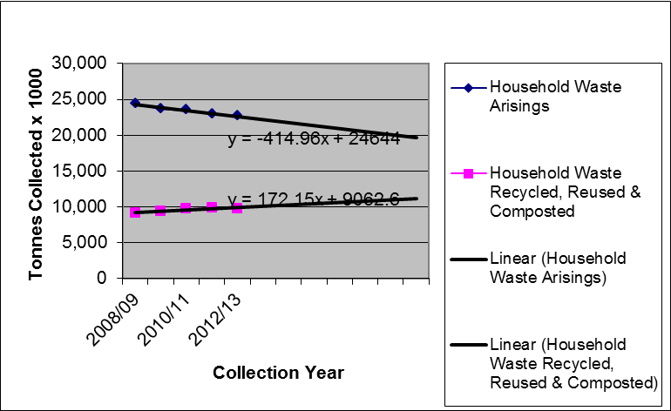
Figure 5. Projected household waste in England between 2008/09 – 2019/20

In 2019/20 the factor (x) from Figure 5 will equal 12 as x=1 in 08/09 Therefore for total household waste collected:
Y = (-414.9 x 12) + 24,644 = 19,664 tonnes (x1000)

And for waste recycled
Y = (172.15 x 12) + 9,062.6 = 11,128.4 tonnes (x1000)

Therefore, in 2019/20 the RRC rate would be 11,128/19,664 = 0.57 or 57%. Thus the 50% national target will have been theoretically achieved. The exercise can be repeated, using less points, by taking more recent data giving results of:

- From 2009/10 (4 points) the RRC rate will potentially be 54%
- From 2010/11 (3 points) the RRC rate will potentially be 51%
- From 2011/12 (2 points) the RRC rate will potentially be 45%

This shows that the potential to meet the 50% target diminishing due to the flattening of the RRC tonnage and therefore, it is unlikely that England will meet the target if that trend continued.

In 2012/13 the household arisings in England were 22.6 million tonnes and the RRC tonnage was 9.8 million tonnes allowing England to achieve the 43.2% RRC rate. Defra (2013b) forecast that English household arisings would be between 20.3 - 24.9 million tonnes in 2020. Therefore, the RRC tonnage would have to rise to between 10.2 - 12.5 million tonnes in 2020 (Figure 6). This equates to an RRC rate rise requirement of between 0.4 and 2.7 million tonnes or an annual rise of between 0.06 and 0.39 million tonnes/year (0.57%/year and 3.1%/year) over the seven year period. From 2008/09, the percentage RRC rate rises have been 2%, 1%, 2% and 0.2%.

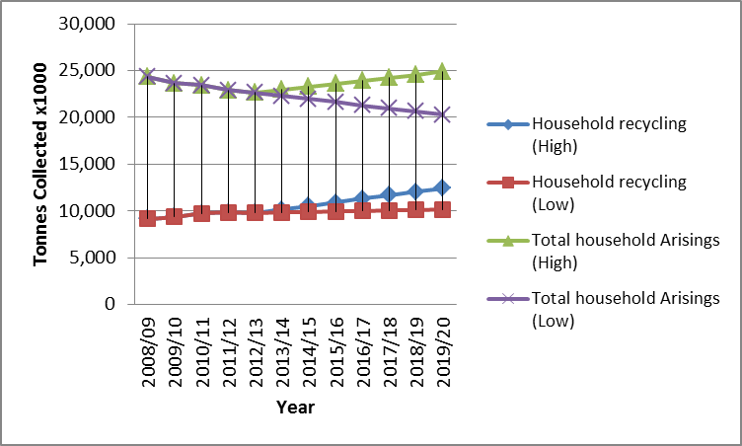
Figure 6. Potential tonnage requirements to meet the 50% target

If the RRC rate stays constant at 9.8 million tonnes and the worst case of 24.9 million tonnes was achieved, then the rate in 2020 could be as low as 39.4%.

5. Discussion
This study has confirmed that most LAs are aware of the 50% national target and that some have already achieved it. However, most low rate authorities are highly unlikely to do so.

5.1. Factors influencing the RRC rate
Various factors influence the RRC rate, however, the main elements were:

5.1.1 Legislation
It is debatable whether the correct formula was chosen for the UK. The UK chose calculation method 3 which created a RRC rate of 43.2% in 2012/13 for England. If it had chosen any of the other calculation methods then the English recycling rate in 2012/13 would potentially have been in the order of: Method 1: 17.4%; Method 2: 20.3%; Method 4: 42.4% (WRAP, 2014d). While none of the formulae would have generated a higher RRC rate, Defra may be right in not wanting to place over-reliance on a prescriptive formula (Parliament, 2014b). As such an approach excludes materials that could potentially be claimed as having been recycled, such as home composted organic waste, organic content of street sweepings and incinerator bottom ash (IBA).

5.1.2 Government policy
With uncertainty over England meeting the 50% target, and the potential threat of infraction proceedings and heavy fines, it may have been expected that Defra would take positive action to guarantee the target is met (Defra, 2013c). Stepping back is not viable as businesses have different interests to Government and voluntary agreements from business do not always work (Alberini et al., 2002, Bomberg, 2007). Most of the participants in this research clearly indicated that Defra should intervene and set out appropriate waste policy measures, and provide additional funding. Most also wanted to see Defra instigating nationwide communications on recycling, providing assistance to local authorities in composting organic waste and introducing PAYT (Hogg, 2014). As WRev2011 does not contain any targets regarding recycling, reuse and composting of household waste it could be argued that there is no incentive for LAs to raise their RRC rate to 50% by 2020.

5.1.3 Collection methods
Multi-stream was the preferred option for high rate authorities, and co-mingling for low rate authorities. The findings suggested that there was no one collection method that dominated for authorities recording high or low RRC rates. Any of the standard dry recyclate collection methods could produce high RRC rates, although the similarity test did confirm that there were differences between the three collection methods. However, it could be argued that the requirement for one method of collecting materials is prohibitive and that it should not be the method that is legislated but the contamination levels and allowing authorities to use whichever collection method best suits their particular local circumstances (Parfitt and Bridgewater, 2011; Abbott et al., 2011; Parliament 2013). There was support for a rise in twin-stream collection of dry recyclates and this collection method could potentially overcome the disadvantages of either multi-stream or co-mingled collections (WRAP, 2010; WYG Environment, 2013).

5.1.4 Reuse, Recycling and Composting
The main reason given for declining waste arisings was the economic downturn, whereby householders have less money to spend and therefore generate less waste. This suggests that as the economy grows, more waste will be generated which will have serious negative implications in meeting the 50% target.

In this study the RRC rate ranged from 22 - 67% across 48 LAs. However, the average waste tonnage collected per household equated to a difference of just 28kg per annum. If it is assumed that the waste composition is likely to be similar then low rate authority households simply did not reuse, recycle and compost as much on average as high rate households. How householders deal with their waste is the vital factor in achieving high RRC rates (Shaw, 2006; Green Alliance, 2014).

With a 2012/13 reuse, recycling and composting ratio of 1:137:55 (by weight) in England (WRAP, 2014b) it could be argued that despite the real importance of reuse it will be extremely difficult to develop it compared to recycling and composting. Therefore, it may be more prudent for LAs to focus on dry recyclate recycling and organic waste, particularly food waste. The largest single tonnage element of RRC is organic waste although home composting cannot be included. The results suggest that low rate authorities simply composted less material, and that charging for organic waste collection is not a barrier to achieving a high RRC rate. Based on this study an average of £45 revenue from each participating household could be achieved and still enable participation, contrary to Hathaway (2014).

It could be argued that the RRC rate as the main metric for household waste is a blunt instrument that does not take into account the main focus of the Waste Hierarchy which is waste prevention (EU, 2008). Indeed, authorities with the optimum arrangement of low waste arisings per household did not equate to having the higher RRC rates. This is especially valid considering that Wrev2011 stated that the cost of LA spend on waste management would be measured per household. The RRC rate being based on tonnage alone is misleading as it places undue emphasis on the heavier/denser materials such as organic waste and paper and reduces the impact of the lighter materials such as plastic and aluminium. It also penalises highly urban areas with minimal garden space. Defra (2013d) confirmed they would measure household arisings per household although they would measure commercial and industrial and demolition waste arisings per unit of gross value added (GVA). It may be that the GVA approach would also be helpful for household waste.

5.1.5 Householder attitude
Studies suggest that between 16-25% of householders are not recycling effectively or are indifferent to the environmental benefits of reuse, recycling and composting (Eunomia 2014; WRAP, 2014d). Householder indifference could be linked to the amount of information received on RRC from the LA, as in this study generally householder communications did not last longer than three months (Martin et al., 2006; Timlett and Williams, 2008).

Schemes with different bin/box/bag colours for the same materials, that collect those materials at different frequencies and with variation between local authorities, are confusing to householders (WRAP, 2012). This can only feed the apathy of some segments of the population (Tonglet et al., 2004; Barr and Gilg, 2005; Timlett and Williams, 2009; Thomas and Sharp, 2013).

5.1.6 Local authority practicalities
A major stated barrier to meeting the 50% target was decreasing budgets (LGA, 2013; NAO, 2014). As authorities have no specific local or regional RRC target to meet, the national target may seem abstract and nothing to do with them as they will not be penalised for not meeting it. A number also cited the need for Councillor willingness to endorse recycling activities as a key issue. Thus a ‘good’ environmental scheme could still flounder if there was no political will to proceed.

Where LAs collect garden waste, it is a difficult decision whether to charge for that service or not. The dilemma concerns obtaining revenue or reduced organic tonnage and householder dissatisfaction if a charge is applied. This research found that five WCAs that charged for garden waste collection had RRC rates between 46 - 62% suggesting that they would potentially achieve the target. Therefore, charging for garden waste collection is not a barrier to high RRC rates.

All high and most low rate authorities stated that they had implemented a collection service change of some description to improve their RRC rate. Service changes were the only reasons for significant positive tonnage changes by high rate authorities, whilst 61% of low rate authorities stated that service change improved their RRC rate. The most popular high rate service change initiative included an ‘all options’ change to the waste collection system for dry recyclate and organic waste. This ‘all options’ change was also undertaken by three low rate authorities suggesting that no barrier exists to its implementation for authority type. The general consensus regarding the main benefits of a service change was that participation increased, leading to additional tonnage being reused, recycled and composted, which in turn boosted RRC rates. Therefore, it could be argued that low RRC rates was not due to householders not recycling at all, rather it was that householders were not recycling, reusing or composting enough.

Contrary to others (e.g. WRAP, 2010; WYG Environment, 2013). the method of collection was not a limiting factor to achieving high RRC rates. However, household waste collection methods came under closer scrutiny when the separate collection requirement of the Waste (England and Wales) Regulations 2011 came into force on 1st January 2015. Local authorities are still free to choose whichever system suits their local circumstances, but if a separate collection is not chosen, they need to justify that it is not necessary or TEEP.

Incentive schemes were utilised in 17% of the LAs, however, no one incentive scheme was preferred. However, the benefits of such schemes for household waste have yet to be proven and householders are minded to participate in recycling schemes regardless of incentives (Shaw and Maynard, 2008; Eunomia, 2014; Serco, 2014).

5.2. Differences between high and low RRC rate authorities

The key difference between the low and high rate authorities was the percentage of organic material composted. Low rate authorities did recycle a higher percentage of dry recyclate but as this is lower by weight compared to organic waste then it does not help in a weight based RRC rate calculation. In general the service changes were more costly per LA for high rate authorities than those for low rates, suggesting that it was a full service change from one collection scheme type to another rather than a single element of change.

Whilst some low rate authorities had plans to undertake initiatives, the majority had none as there was no local requirement to achieve the national 50% recycling target. There should be intervention by Defra to stimulate household waste reduction and additional recycling in preparation for when the RRC rate potentially increases to 70% in 2030 (Lets Recycle, 2014). However, the chosen method of RRC calculation does not allow new materials to be added unless they are derivatives of paper, metal, glass or plastic.

Both high rate and low rate authorities viewed lack of budget as equally important. The significant jump in RRC rates for high rate authorities suggests that investment had taken place to implement waste collection infrastructure initiatives between 2008/09 and 2012/13. Around half of the low rate authorities had also invested in a service change. However, the high rate authorities had spent approximately 1.5 times more.

6. Conclusions

It is unlikely that England will meet the 50% target in 2020. Indeed, if for example, there is an increase in household waste arisings or poor weather hampering organic waste collection, then the RRC rate could be as low as 39%. Low rate authorities composted much less than their high rate counterparts. While contrary to Dahlen et al. (2009) urbanisation was not a significant barrier, a lack of garden space is important when 87% of the organic waste collected is garden waste. Therefore, authorities with lower garden areas will be at a disadvantage when RRC rates are compared. This also points towards the target being a crude device to measure recycling performance as it is weight dependent. This bias places no benefit on the scarcity or value of a material meaning that a bin of garden waste has the same recycling worth as a bin of aluminium waste.

It is always going to be difficult for LAs to engage some householders, as there will be practical issues such as: flats and terraced housing where bin placement is difficult, transient populations, non-English speaking householders, lack of understanding and plain indifference. Thirteen percent of the low rate authorities in this study cited incentive schemes as their main initiative in the study period. However, it may be that householders would recycle more through improvements to structural and promotional aspects of the collection scheme than through financial incentives.

To improve the RRC rate, the preferred option was to implement a service change that allowed AWC for dry recyclate and garden waste with weekly collection for food waste. There was no preference between the types of dry recyclate collection method. As many of the ‘old’ collection systems have now been upgraded it makes future initiatives to improve reuse, recycling and composting more challenging.

It is evident that organic waste is the key stream as it is the single largest RRC tonnage component (dry recyclate has a higher tonnage but consists of a number of materials). Despite the findings that charging for garden waste was not a barrier to high RRC rates it is still an issue for LAs that charging may reduce household participation. It is suggested that where no existing charge is made for garden waste, that Defra should intervene. This could potentially include financial support to provide or upgrade a garden waste collection scheme with subsidies on a low entry charge for householders to purchase garden and food waste collection bins. This would provide revenue and potentially increase organic waste tonnage composted if the charge was not seen as excessive.

Collection charges will never be popular and the initial level of charge is critical in determining the level of householder participation, however, once established the charges could potentially be gradually increased more in-line with the £45 average.

Even though this study was focused on England, it nevertheless has relevance across Europe, where driven by legislation, there is an increasing need for member states to manage their waste more sustainably. The findings suggest that LAs wishing to improve their RRC rate should focus on organic waste as this is the largest single tonnage element. Consideration should also be given to structural changes to the collection service including AWC for dry recyclate and garden waste with a separate weekly collection of food waste. Government should also provide clear direction, guidance and support, particularly in light of the current economic challenges being faced. Crucially, initiatives to prevent the generation of the waste in the first place should also be incorporated. At a wider level, there perhaps should also be a re-examination of the target-based approach being employed. None of the four formulae options take into account the primary objective of the Waste Hierarchy which is to prevent waste occurring in the first instance. When the RRC rate is considered against the lowest amount of waste generated per household the existing leading local authorities move considerably down the league table. This suggests that the existing method of calculating the RRC rate can reward authorities that produce excessive waste per household. It is only through a more coordinated, holistic and focused approach, that recovery of value and resource security can best be facilitated across the regions in Europe and beyond.
References

Abbott A, Nandeibam S, O’Shea L. Explaining the variation in household recycling rates across the UK. Ecol Econ 2011; 70:2214-2223.

Alberini A, Segerson K. Assessing voluntary programs to improve environmental quality. Env Res Econ 2002; 22: 157-184.

Barr S, Gilg AW. Conceptualising and analyzing household attitudes and
actions to a growing environmental problem: development and application of a
framework to guide local waste policy. App Geog 2005; 25, 3: 226–247.

Beasley Associates Ltd. The Defra waste review 2011 : Reflections from industry. 2011 Available from : http://beasleyassociates.com/pdf/SummaryReport.pdf (Accessed 20th March 2014).

Bomberg E. Policy learning in an enlarged European Union: environmental NGOs and new policy instruments. J Eur Public Policy 2007; 14: 248-268.

Dahlén L, Aberg H, Lagerkvist A, Berg P. Inconsistent pathways of household waste. Waste Man 2009; 29, 6:1798-1806.

DECC. The Climate Change Act 2008, London: HMSO; 2008

Defra . Waste Strategy for England 2007, London : HMSO; 2007

Defra (2008a) A framework for pro-environmental behaviours. [online] Available from http://archive.defra.gov.uk/evidence/social/behaviour/documents/behaviours-jan08-annexes.pdf (Accessed 4th March 2014).

Defra (2008b) Financial incentives for waste management : Factsheet for local authorities. [online]. Available from : http://archive.defra.gov.uk/environment/waste/strategy/incentives/documents/incentives-lafactsheet.pdf (Accessed 21st August 2014).

Defra. Consultation on amending the Waste Regulations 2011on the separate collection of recycling. 2012. Available from : https://www.gov.uk/government/uploads/system/uploads/attachment_data/file/82467/waste-regs-condoc-120222.pdf (Accessed 3rd July 2014).

Defra. Statistics on waste managed by local authorities in England in 2012/13. 2013a. Available from : https://www.gov.uk/government/uploads/system/uploads/attachment_data/file/255610/Statistics_Notice1.pdf (Accessed 6th February 2014).

Defra. Forecasting 2020 waste arisings and treatment capacity. 2013b. Available from : https://www.gov.uk/government/uploads/system/uploads/attachment_data/file/251567/pb13883-forecasting-2020-waste-arisings-131017.pdf (Accessed 4th June 2014).

Defra. Dan Rogerson MP letter to stakeholders. 2013c. Available from : https://www.gov.uk/government/uploads/system/uploads/attachment_data/file/255508/waste-stakeholder-letter-131106.pdf (Accessed 10th November 2013).

Defra. Consultation on the waste prevention programme for England. 2013d Available from : https://consult.defra.gov.uk/waste/waste_prevention/supporting_documents/Waste%20prevention%20programme%20consultation%202013.pdf (Accessed 3rd September 2014).

Defra. ENV18 – Local authority collected waste : annual results tables. 2014 Available from : https://www.gov.uk/government/statistical-data-sets/env18-local-authority-collected-waste-annual-results-tables (Accessed 3rd March 2014).

Dresner S, Ekins P. Charging for domestic waste in England: Combining environmental and equity considerations. Res, Cons Recyc 2010; 54: 1100-1108.

EA (Environment Agency). Leaf litter in street sweepings : Investigation into collection and treatment. 2013. Available from : https://www.gov.uk/government/uploads/system/uploads/attachment_data/file/291575/LIT_8942_4547cc.pdf (Accessed 27th April 2014).

EU. Directive 2008/98/EC. 2008. Available from : http://eur-lex.europa.eu/LexUriServ/LexUriServ.do?uri=OJ:L:2008:312:0003:0030:en:PDF (Accessed 8th August 2014).

Eunomia. Incentivising recycling. The Loop 2014a; 47: 19-21.

European Environment Agency. Managing municipal solid waste. 2013. Available from: http://www.eea.europa.eu/publications/managing-municipal-solid-waste (Accessed 12th September 2014).

FEUD (Foundation for EU Democracy) (2008) Consolidated reader-friendly edition of the Treaty on European Union (TEU) and the Treaty on the Functioning of the European Union (TFEU) as amended by the Treaty of Lisbon (2007). [online]. Available from : http://www.eudemocrats.org/fileadmin/user_upload/Documents/D-Reader_friendly_latest%20version.pdf (Accessed 1st December 2014).

Green Alliance. Wasted opportunities: Smarter systems for resource recovery. 2014. Available from : http://www.green-alliance.org.uk/resources/Wasted_opportunities.pdf (Accessed 25th October 2014).

Hage O, Soderholm P. An econometric analysis of regional differences in household waste collection: The case of plastic packaging waste in Sweden. Waste Manage 2008; 28: 1720-1731.

Hathaway R. Goodbye, England’s rise: why have household recycling rates stalled? 2014. Available from : http://www.isonomia.co.uk/?p=2663 (Accessed 5th August 2014).

Hogg D. Withdrawal symptoms: why Defra still has a role in waste. 2014. Available from: http://www.isonomia.co.uk/?p=2996#rpctoken=1073626342&forcesecure=1 (Accessed 4th June 2014).

Husaini I, Garg A, Kim K, Marchant J, Pollard S, Smith R. European household waste management schemes : Their effectiveness and applicability in England. Res, Conserv Recyc 2007; 51: 248-263.

Lane G, Wagner T. Examining recycling container attributes and household recycling practices. Res, Conserv Recyc 2013; 75: 32-40.

Lets Recycle. Defra cautious over cost of EU resource proposals. 2014. Available from : http://www.letsrecycle.com/news/latest-news/defra-cautious-over-cost-of-eu-resource-proposals/ (Accessed 5th July 2014).

LGA (Local Government Association). LGA response to the local government finance settlement. 2013. Available from : http://www.local.gov.uk/media-releases/-/journal_content/56/10180/5782122/NEWS (Accessed 20th July 2014).

MRW (Materials Recycling World). Scottish recycling rate hits 41%. 2013. Available from : http://www.mrw.co.uk/news/scottish-recycling-rate-hits-41/8652397.article (Accessed 16th October 2014).

Martin M, Williams I, Clark M. Social, cultural and structural influences on
household waste recycling: A case study. Res, Conserv Recyc 2006; 48: 357-395.

Mee N, Clewes D, Phillips P, Read A. Effective implementation of a marketing communications strategy for kerbside recycling : a case study from Rushcliffe, UK. Res, Conserv Recyc 2004; 42: 1-26.

NAO (National Audit Office). Financial sustainability of local authorities 2014. 2014. Available from : http://www.nao.org.uk/wp-content/uploads/2014/11/Financial-sustainability-of-local-authorities-2014-summary.pdf (Accessed 1st December 2014).

NIEA (Northern Ireland Environment Agency). Northern Ireland local authority municipal waste management statistics. 2013. Available from : http://www.doeni.gov.uk/lac-municipal-waste-2012-13.pdf (Accessed 15th March 2014).

Parfitt JP, Bridgewater E. Household waste trends in the UK – The impact of local policies on waste arisings. 2011. Available from : http://warrr.org/768/
(Accessed 16th August 2014).

Parliament. Bin collection – Alternate weekly collection. 2013. Available from : http://www.parliament.uk/business/publications/research/briefing-papers/SN05988/bin-collection-alternate-weekly-collection (Accessed 20th October 2014).

Parliament. Waste management – further evidence sessions. 2014a. Available from : http://www.parliament.uk/business/committees/committees-a-z/commons-select/environment-food-and-rural-affairs-committee/news/waste-management-ev-sess-3/ (Accessed 10th July 2014).

Parliament. Waste management in England. 2014b. Available from : http://www.publications.parliament.uk/pa/cm201415/cmselect/cmenvfru/241/24102.htm (Accessed 17th October 2014).

Perrin D, Barton J. Issues associated with transforming household attitudes and opinions into materials recovery: a review of two kerbside recycling schemes. Res, Conserv Recyc 2001; 33:61-74.

Resource. England recycling rate rises by just 0.1 per cent in 2013. 2014. Available from : http://resource.co/resource-use/article/england-recycling-rate-rises-just-01-cent-2013-3204 (Accessed 5th September 2014).

Robinson G, Read A. Recycling behaviour in a London Borough: Results from large-scale household surveys. Res, Conserv Recyc 2005; 45: 70-83.

Serco. Investigating the impact of recycling incentive schemes. 2014. Available from : http://www.serco.com/Images/Serco%20Eunomia%20Incentives%20Full%20Report_tcm3-44276.pdf (Accessed 3rd September 2014).

Shaw P, Lyas J, Hudson M. Quantitative analysis of recyclable materials composition : Tools to support decision making in kerbside recycling. Res, Conserv Recyc 2006; 48: 263-279.

TSG (The Scottish Government). Infringements of EU Legislation. 2014. Available from: http://www.scotland.gov.uk/Topics/International/Europe/Legislation/Infractions (Accessed 21st June 2014).

Thomas C, Sharp V. Understanding the normalisation of recycling behaviour and its implications for other pro-environmental behaviours: a review of social norms and recycling. Res, Conserv Recyc 2013; 79: 11-20.

Timlett R, Williams I. Public participation and recycling performance in England:
A comparison of tools for behaviour change. Res, Conserv Recyc 2008; 52: 622-634.

Tonglet M, Phillips P, Bates M. Determining the drivers for householder
pro-environmental behaviour: waste minimization compared to recycling. Res, Conserv Recyc 2004; 42: 27-48.

Waste Data Flow. 2014.. Available from : http://www.wastedataflow.org/ (Accessed 5th September 2014).

Welsh Government. Welsh recycling rate continues to rise. 2014 Available from: http://wales.gov.uk/newsroom/environmentandcountryside/2014/140213wasterecyclingstats/?lang=en (Accessed 15th March 2014).

Williams ID, Cole C. The impact of alternate weekly collections on waste arisings. Sci Tot Env 2013; 445-446: 29-40.

WRAP. Barriers to recycling at home. 2008. Available from : http://www.wrap.org.uk/sites/files/wrap/Barriers_to_Recycling_Summary_Report.pdf (Accessed 2nd May 2014).

WRAP. Analysis of kerbside dry recycling performance in the UK 2008/09. 2010. Available from : http://www.wrap.org.uk/sites/files/wrap/EVA143-000%20Kerbside%20Dry%20Benchmarking%20UK%2008-09%20Report%20FINAL%20for%20publication%20V2%201.pdf (Accessed 4th June 2014).

WRAP Cymru. Kerbside collection options : Wales. 2011. Available from: http://www.wrapcymru.org.uk/sites/files/wrap/Kerbside%20Collections.pdf (Accessed 7th October 2014).

WRAP. Kerbside collection of plastic bottles guide. 2012a. Available from: http://www.wrap.org.uk/sites/files/wrap/Plastic_bottles_kerbside_collection_guide_v2.pdf (Accessed 3rd March 2014).

WRAP. Waste less, recycle more – yes, but how? 2012b. Available from: http://www.wrap.org.uk/blog/2012/09/waste-less-recycle-more-yes-how (Accessed 5th March 2014).

WRAP. 50% recycling rate – it’s not going to be easy. 2014a. Available from: http://www.wrap.org.uk/node/25283 (Accessed 11th August 2014).

WRAP. 3Rs tracking survey : Recycling attitudes and reported behaviour. 2014b Available from: http://www.wrap.org.uk/sites/files/wrap/3Rs%20Recycling%20Highlights%20-%202014%20-%20Final%20121214%20PUBLISHED%20-%20PDF.pdf (Accessed 19th December 2014).

WRAP. Local authority waste and recycling information portal. 2014c. Available from: http://laportal.wrap.org.uk/ (Accessed 5th March 2014).

WRAP. Composition of waste in England. 2014d. Pers comm.

WYG Environment. Review of kerbside collection schemes in the UK 2010/11. 2012. Available from: http://www.ecolateral.org/MunicipalRecyclingReviewWYGApril2012.pdf (Accessed 18th March 2014).

WYG Environment. Review of kerbside collection schemes in the UK 2011/12. 2013. Available from: http://www.wyg.com/uploads/files/pdfs/Kerbside-Recycling-Report-2011-12.pdf (Accessed 18th March 2014).

