TITLE
A Comparison of Two Anaerobic Test Measurement Systems using an Upper Body Wingate Test

AUTHORS
Chris Talbot¹, Tony D. Kay¹, Natalie Walker¹, Mike J. Price²

AFFILIATION
¹Sport, Exercise and Life Sciences, University of Northampton, Park Campus, Boughton Green Road, Northampton NN2 7AL, United Kingdom
²Biomolecular and Sports Sciences, Faculty of Health and Life Sciences, Coventry University, James Starley Building, Priory Street, Coventry CV1 5FB, United Kingdom

ADDRESS FOR CORRESPONDENCE
Chris Talbot¹, The University of Northampton, Sport, Exercise and Life Sciences, Park Campus, Boughton Green Road, Northampton NN2 7AL, UK.
Email: chris.talbot@northampton.ac.uk

ABSTRACT
This study aimed to compare performance measures acquired by two different Wingate Anaerobic Test systems; Cranlea and Monark. Twenty participants undertook 58 Wingate tests against a 4% body mass resistive load on a cycle ergometer adapted for arm cranking. Corrected peak power output (PP; W) was recorded using 1 rev min–1, 0.5, 1 and 5 s averages and mean power output (MP; W). The Cranlea system recorded the greatest PP (589 ± 267 W) compared with the Monark (546 ± 267 W; P < 0.001). The PP using all other methods was also greater for the Cranlea compared with the Monark system (P < 0.001) with mean differences of 55 ± 18 W for 1 s averages and 22 ± 18 W for MP. Correlations between all PPs were strong (r = 0.99 – 0.97; P < 0.001). In conclusion, although the Cranlea system provides a consistently greater corrected PP it may not be enough to substantially differentiate between systems.

KEYWORDS arm cranking, power output, upper body exercise, female, male

INTRODUCTION
The Wingate Anaerobic Test (WAnT) allows the assessment of power output during short duration all out cycling. Since its development in 1974 (Ayalon, Inbar, & Bar-Or, 1974) the WAnT has been used extensively in sport and exercise science research examining various aspects of performance such as: the effects of training (Astorino, Allen, Roberson, & Jurancich, 2012; Ziemann et al., 2011), circadian rhythms (Hill & Smith, 1991) and determination of peak power output (PP) and mean power output (MP) in male and female athletes (Nindl, Mahar, Harman, & Patton, 1995). The WAnT is considered to be a reliable test for PP and MP for both the lower body (Inbar, Bar-Or, & Skinner, 1996) and upper body (Jacobs, Johnson, Somarriba, & Carter, 2005) as well as for minimum power output (Jacobs, Mahoney, & Johnson, 2003). Testing of the upper body is important for those individuals involved in upper body sports such as canoeing, kayaking and wheelchair racing (Smith & Price, 2007) and in assessing the functional capacities of those individuals unable to use their legs (Jacobs et al., 2003, 2005). In comparison to lower body WAnTs, fatigue may be greater (Inbar et al., 1996) and the contribution of the energy systems, especially the anaerobic lactic system, may differ in proportion to lower body WAnTs (Lovell et al., 2013). The use of arm WAnTs should minimise the irregular application of the brake load observed in lower body WAnTs due to participants gripping and moving the handle bars (Franklin, Gordon, Davies, & Baker, 2008). Additionally, an examination of the literature revealed that there are a limited number of studies pertaining to WAnTs of the upper body when compared with the lower body, especially in female participants.

In recent years, two commercially available software programmes have been available to record data from a Monark ergometer for calculation of the associated WAnT performance indices; Cranlea Wingate (v. 4.00; Cranlea & Company, Birmingham, UK) and Monark Wingate (v. 2.20; Monark, Varberg, Sweden). Performance data using the Monark software have only been recently published (Hazell, Macpherson, Gravelle, & Lemon, 2010; Rana, 2006; Wilson et al., 2013; Zagatto, Papoti, & Gobatto, 2008) whereas the Cranlea software has been used for a number of studies prior to the development of the Monark software (Baker, Gal, Davies, Bailey, & Morgan, 2001; Balmer, Bird, Richard, Doherty, & Smith, 2004; Franklin et al., 2008; Micklewright, Alkhatib, & Beneke, 2006; Smith, Price, Davison, Scott, & Balmer, 2007). Although both analysis programmes provide the same performance indices (peak power output, mean power output and fatigue index) the raw data for these calculations is collected via different methods. The Monark system records from a single sensor located within the crank of the ergometer and raw data are processed based on each revolution of the flywheel. The Cranlea system records from the perimeter of the flywheel enabling raw data to be collected at 18.2 Hz. Differences in sample rates may also have an effect on recorded power output as the sample rate for the Cranlea system is greater than the 5 Hz recommended by Santos, Novaes, Reis, & Giannella-Neto, 2010 (18.2 Hz) and the Monark system, being dependent on a single sensor, is less than 5 Hz. When calibrating for moment of inertia and friction torque, the Monark programme assumes a standard figure for inertia (0.91) while the Cranlea programme requires a pre-test calibration routine to determine these figures. Differences in data acquisition could affect the performance outcome values as has been demonstrated with mechanical versus electro-magnetic (Balmer et al., 2004) and flywheel versus crank electrical (Dotan, 2006) assessment.

As both programmes can be run simultaneously and no previous comparison of the functionality between the two systems has been reported, the aim of this study was to compare performance indices across both software systems. We hypothesized that the Cranlea software would calculate a higher power output due to the greater sampling frequency.

METHOD
Participants
Twenty healthy participants 11 males (26.1 ± 9.2 yrs; 177.8 ± 4.9 m; 87.0 ± 18.3 kg) and nine females (22.2 ± 3.7 yrs; 164.8 ± 4.8 m; 67.9 ± 16.8 kg) volunteered to participate in this study, after giving written, informed consent following ethical approval from the Institutional Ethics Committee. None were specifically upper body trained but all took part in regular physical activity at a recreational level at least twice a week. All participants provided written informed consent and completed a health screening questionnaire prior to each exercise session. All participants completed three upper body Wingate anaerobic tests as part of a familiarisation process for a larger study. Therefore, 60 tests were able to be analysed. However, each of the systems failed on one occasion and therefore only 58 tests are reported. Recording more trials provided a more powerful analysis. In addition, each participant had a minimum of 24 hours between tests.

Wingate Anaerobic Test
On arrival at the laboratory participants rested quietly for 15 min while a heart rate monitor was attached and resting heart rate recorded. Each exercise test was undertaken on a Monark 894E cycle ergometer (Monark Exercise AB, Sweden) adapted for upper body exercise. Participants sat on a sturdy metal chair with a small padded back rest. To minimise movement of the chair each of the four legs of the chair were bolted to a wooden board. The participant was positioned such that the centre of their glenohumeral joint was horizontal with the centre of the ergometer crank arm to optimise power output (Leicht & Spinks, 2007; Sawka, Foley, Pimental, Toner, & Pandolf, 1983). This position was checked using a metre rule and spirit level to line the two points up horizontally. The chair height was adjusted to within ±10 mm by a series of wooden boards and rubber matting. The participants were instructed to find the most comfortable horizontal distance from the arm crank ergometer, but not to have their elbows locked at the point of furthest extension (Leicht & Spinks, 2007; Sawka et al., 1983). During the warm-up, participants could adjust their horizontal position from the arm crank ergometer if necessary. To increase inter-test reliability the chair position was noted and kept the same for all tests (Leicht & Spinks, 2007). Participants were instructed to keep their feet shoulder width apart with their knees at 90° to the floor and not to move their feet during each exercise test.

After resting heart rate was recorded participants completed a 5 min warm-up at 60 rev min–1 on the unloaded ergometer including three 3–4 s practice sprints. After 2 min a countdown of ‘3, 2, 1, Go’ was given to initiate the practice sprints. On the command of ‘1’ the load (4% of body mass; Smith & Price, 2007) was released automatically using a manual trigger, and on the command ‘Go’ participants were instructed to crank as hard and as fast as they could. After the 3–4 s practice sprint the arm crank ergometer was unloaded to allow participants to continue arm cranking at 60 rev min–1. At 3 and 4 min of the warm-up this process was repeated. Participants then continued unloaded arm cranking until the 5 min warm-up duration was complete. Once participants indicated that they were ready to begin the test they exercised at 60 rev min–1 on the unloaded ergometer and were then given a countdown of ‘3, 2, 1, Go’. On ‘1’ the test resistance was applied and on ‘Go’ participants arm cranked as fast as possible for 30 s. Verbal encouragement was provided throughout the test. At the end of the test the load was removed and the participant continued to exercise at 60 rev min–1 on the unloaded ergometer for at least 5 min.

Performance indices of PP, MP, and peak cadence were calculated from each analysis system. Although it is possible to extract data from both systems for further analysis, raw data from the Monark system do not provide data for the full duration of the test. Therefore, a test duration of 24 s was available for a comparison of mean power between systems. This duration was still sufficient to provide an accurate indication of mean power and fatigue index (Laurent, Meyers, Robinson, & Green, 2007; Stickley, Hetzler, & Kimura, 2008) and did not affect analysis of the peak power output with values typically occurring between 4-8 s. The following performance indices were calculated and analysed; PP over one revolution (PP1rev; Monark only), PP over 0.5 s (PP0.5s; Cranlea only), PP over 1 s (PP1s), MP over 24 s duration, cadence (rev min–1) at PP, mean cadence (rev min–1), time to PP, minimum power output at 24 s using a 1 s mean (POmin) and fatigue index (FI; PP1s – POmin/PP1s). Additionally, to provide an assessment of averaging techniques the raw data for Cranlea peak power was also averaged every 0.5 s providing comparison of the 0.5, 1 and 5 s PP values. All power variables are in Watts (W) and were corrected for flywheel acceleration and deceleration (Lakomy, 1986).

Statistical Analysis
Performance variables between software systems and gender differences were analysed by paired T-tests using SPSS (version 17.0, SPSS, Chicago, IL, USA). Data are expressed as mean ± standard deviation. Peak power output values for Cranlea (0.5, 1 and 5 s averages) were analysed by one-way analysis of variance. A Bonferroni post hoc test was used to detect where significant differences occurred. Significance was accepted at the level of P < 0.05 however, where greater significance was attained this is specifically noted (i.e. P < 0.01). The agreement between PP values was determined by calculating the bias and limits of agreement according to the methods of Bland and Altman (1986).

RESULTS
Performance Indices: Male versus Female
Key performance indices for the male and female participants for both the Cranlea and Monark systems are shown in Table 1. There were significant differences (P < 0.01) between male and female participants for PP1s and MP from both measurement systems. There was no significant difference between male and female time to PP1s and end heart rate (bpm–1).

Peak Power Output
A range of PP values from 179 W to 1000 W were recorded for the Cranlea software (PP1s), from 137 W to 911 W for Monark (PP1s) and from 216 W to 1192 W for Monark software (PP1rev). All PP values from the Cranlea system were greater than those for the Monark system (P < 0.001; Table 2). Peak power output averaged over 1 s from the Cranlea system was greater than for the Monark system (P < 0.001) with a mean difference of 55 (±38) W. The PP1rev reported by the Monark system was greater than the 1 s means of both systems (P < 0.001). All PP indices from both systems were strongly correlated (r ≥ 0.97; P < 0.001).

Mean Power Output
Mean power output between systems was greatest for the Cranlea system with a difference of 22 ± 14 W (P < 0.001) when compared with the Monark software. There were also differences for mean cadence with a difference of 2 rev min–1 (P < 0.001) greater for the Cranlea system when compared with the Monark software. No differences were observed for peak cadence, time to peak power or minimum power output (P > 0.05). Fatigue index was greater for the Cranlea system (P < 0.001).

Relationships between Variables
Strong correlations were observed between variables, in particular between measures of PP and MP (Table 2). The agreement between the PP values is shown in Figures 1 and 2. The mean bias (difference) between Cranlea PP1s and Monark PP1rev was −33 W with limits of agreement between 59 W and −125 W. When comparing the Cranlea PP0.5s and Monark PP1rev the mean bias was 43 W with limits of agreement between 181 W and −95 W. Bland-Altman plots demonstrated the closest agreement between the Cranlea PP1s and PP0.5s and Monark PP1rev (Figures 1 and 2). As power output increased there was a tendency for the disparity of measurements to increase (i.e. heteroscadasticity).

Averaging Duration
There was a significant difference between PP values from the Cranlea software when averaged over 0.5, 1 and 5 s durations (P < 0.05). Peak power output values decreased as sample duration increased and were 589 (±267), 513 (±239) and 443 (±216) W, respectively (P < 0.05). Post-hoc analysis revealed differences between each pairwise comparison (P < 0.05).

DISCUSSION
The population sample is representative of the range of power outputs reported in the literature for upper body WAnTs (Smith & Price, 2007; Smith et al., 2007). Mean power output values for the female and male participants were similar to those reported for recreationally active participants (Lovell et al., 2011; Smith et al., 2007; respectively). Furthermore, PPs were lower for the female participants than the male participants. Current power outputs are therefore representative of the training status and gender of the participants.

The results of this study demonstrate that there are significant differences in power output between the Cranlea and Monark measurement systems. When considering the PP values provided by each system the bias between PP values was between 33 W to 43 W. This value is greater than; the 5 W observed for test re-test values for corrected PP reported for upper body WAnTs in a similar population examining an optimal loading strategy (Smith et al., 2007), greater than the values of <5 W observed for test re-test PP values (uncorrected) in persons with spinal cord injury (Jacobs et al., 2003, 2005) and greater than both PP (13 W and 2 W) and MP (19 W and 10 W) values from lower body WAnTs using two resistive loadings (Patton, Murphy, & Frederick, 1985). Differences in the two systems are therefore greater than may be expected for daily variation. However, strong correlations were observed between each PP value, which suggests that both systems produced appropriate PP estimates but results may not be used interchangeably.

The comparison of data averaging durations elicited differences in PP values. Interestingly, the PP values were still greater using Cranlea software regardless of the averaging duration. Lower PP values from longer averaging durations has been previously reported (Franklin et al., 2008; Lakomy, 1986). Sampling time can therefore have a significant impact on the magnitude of the power output recorded. In the present study there was a 15% increase in PP when the sample time was reduced from 5 s to 1 s and a further 15% increase when reduced from 1 s to 0.5 s. These findings are lower than previously found for 5 s averages but greater for 0.5 s averages (Lakomy, 1986) and may suggest different muscular and biomechanical interactions for arm crank ergometry when compared with leg ergometry (Kang, Chaloupka, Mastrangelo, & Angelucci, 1999; Leicht & Spinks, 2007; Lovell et al., 2013).

The main difference between systems was for PP. As a result of this the FI calculation also resulted in significant differences between systems as the FI calculation involves PP values. As cadence at PP and the POmin were not different between systems, the difference in PP must be due to the flywheel initially accelerating and also potentially the use of different moment of inertia values in calibration. Variations in the software algorithm used by each system to calculate corrected power could account for some of the observed differences in corrected power output (Balmer et al., 2004). Although unlikely to be a significant contribution, as time to peak power was not significant, to start recording power the Cranlea system required the pressing of a computer key and the Monark system required the pressing of a trigger to release a solenoid holding the WAnT load. Discrepancies in when the systems started to record power could have contributed to some of the observed differences in power output. Therefore, system differences are unlikely to affect uncorrected PP values. However, the time to PP was not different between systems. As this is another important index of performance the difference between systems appears only to be in PP measures, which are affected by the data averaging duration and most likely other methodological issues, such as use of an immediate flywheel loading procedure (Smith et al., 2007) or loading the flywheel once a cadence above 100 rev min–1 has been reached (Jacobs et al., 2003, 2005), and which have differed between studies. The latter factors are more likely to result in significant performance difference of greater magnitude than produced by the software systems.

CONCLUSION
Peak power output achieved from the Wingate anaerobic test and FI calculations are affected by the analysis system used and the duration of the data averaging period. Although differences in PP are evident between systems, and greater than the daily expected variation, the difference is not likely great enough to affect the discrimination of athletic groups based on PP or the increases likely to be achieved during training interventions. This study has also provided an indication of differences that may be expected when different data analysis methods are undertaken and also the expected values for the under-reported population of female participants.

REFERENCES
Astorino, T. A., Allen, R. P., Roberson, D. W., & Jurancich, M. (2012). Effect of highintensity interval training on cardiovascular function, VO2max, and muscular force. Journal of Strength & Conditioning Research, 26(1), 138–145.
Ayalon, A. O., Inbar, O., & Bar-Or, O. (1974). Relationships among measurements of explosive strength and anaerobic power. In R. C. Nelson & C. A. Morehouse (Eds) International series on sports sciences. Vol 1: Biomechanics IV (2nd edn, pp. 572–577). Baltimore: University Park Press.
Baker, J., Gal, J., Davies, B., Bailey, D., & Morgan, R. (2001). Power output of legs during high intensity cycle ergometry: Influence of hand grip. Journal of Science and Medicine in Sport, 4(1), 10–18.
Balmer, J., Bird, S. R., Richard, D. R. C., Doherty, M., & Smith, P. M. (2004). Mechanically braked Wingate powers: Agreement between SRM, corrected and conventional methods of measurement. Journal of Sports Sciences, 22, 661–667.
Bland, M., & Altman, D. G. (1986). Statistical methods for assessing agreement between two methods of clinical measurement. The Lancet, 327(8476), 307–310.
Dotan, R. (2006). The Wingate anaerobic test past and future and the compatibility of mechanically versus electro-magnetically braked cycle-ergometers. European Journal of Applied Physiology, 98(1), 113.
Franklin, K. L., Gordon, R. S., Davies, B., & Baker, J. S. (2008). Assessing accuracy of measurements for a Wingate Test using the Taguchi method. Research in Sports Medicine, 16(1), 1–14.
Hazell, T. J., Macpherson, R. E. K., Gravelle, B. M. R., & Lemon, P. W. R. (2010). 10 or 30-s sprint interval training bouts enhance both aerobic and anaerobic performance. European Journal of Applied Physiology, 110(1), 153–160.
Hill, S. W., & Smith, J. C. (1991). Circadian rhythm in anaerobic power and capacity. Canadian Journal of Sport Sciences, 16(1), 30–32.
Inbar, O., Bar-Or, O., & Skinner, J. (1996). The Wingate Anaerobic Test. Champaign, IL: Human Kinetics.
Jacobs, P. L., Johnson, B., Somarriba, G. A., & Carter, A. B. (2005). Reliability of upper extremity anaerobic power assessment in persons with tetraplegia. The Journal of Spinal Cord Medicine, 28, 109–113.
Jacobs, P. L., Mahoney, E. T., & Johnson, B. (2003). Reliability of arm Wingate Anaerobic Testing in persons with complete paraplegia. The Journal of Spinal Cord Medicine, 26, 141–144.
Kang, J., Chaloupka, E. C., Mastrangelo, M. A., & Angelucci, J. (1999). Physiological responses to upper body exercise on an arm and a modified leg ergometer. Medicine & Science in Sports & Exercise, 31, 1453–1459.
Lakomy, H. K. (1986). Measurement of work and power output using friction-loaded cycle ergometers. Ergonomics, 29, 509–517.
Laurent, M. C., Meyers, M. C., Robinson, C. A., & Green, M. G. (2007). Cross-validation of the 20- versus 30-s Wingate anaerobic test. European Journal of Applied Physiology, 100, 645–651.
Leicht, A. S., & Spinks, W. L. (2007). Effect of shoulder angle on physiological responses during incremental peak arm crank ergometry. Journal of Sports Sciences, 25, 443–452.
Lovell, D., Kerr, A., Wiegand, A., Solomon, C., Harvey, L., & McLellan, C. (2013). The contribution of energy systems during the upper body Wingate anaerobic test. Applied Physiology, Nutrition, and Metabolism, 38, 216–219.
Lovell, D., Mason, D., Delphinus, E., Eagles, A., Shewring, S., & McLellan, C. (2011). Does upper body strength and power influence upper body Wingate performance in men and women? International Journal of Sports Medicine, 32, 771– 775.
Micklewright, D., Alkhatib, A., & Beneke, R. (2006). Mechanically versus electromagnetically braked cycle ergometer: performance and energy cost of the Wingate Anaerobic Test. European Journal of Applied Physiology, 96, 748–751.
Nindl, B. C., Mahar, M. T., Harman, E. A., & Patton, J. F. (1995). Lower and upper body anaerobic performance in male and female adolescent athletes. Medicine and Science in Sports and Exercise, 27, 235–241.
Patton, J. F., Murphy, M. M., & Frederick, F. A. (1985). Maximal power outputs during the Wingate Anaerobic Test. International Journal of Sports Medicine, 6, 82–85.
Rana, S. R. (2006). Effect of the Wingate test on mechanomyography and electromyography. Journal of Strength & Conditioning Research, 20, 292–297.
Santos, E. L., Novaes, J. S., Reis, V. M., & Giannella-Neto, A. (2010). Low sampling rates bias outcomes from the Wingate test. International Journal of Sports Medicine, 31, 784–789.
Sawka, M. N., Foley, M. E., Pimental, N. A., Toner, M. M., & Pandolf, K.B. (1983). Determination of maximal aerobic power during upper-body exercise. Journal of Applied Physiology: Respiratory, Environmental and Exercise Physiology, 54(1), 113–117.
Smith, P. M., & Price, M. J. (2007). Upper-body exercise. In E.M. Winter, A. M. Jones, R. C. R. Davison, P. D. Bromley, & T. H. Mercer (Eds.), BASES Sport and Exercise Physiology Testing Guidelines. Oxon, UK: Routledge. (1st edn., vol. 2, pp. 138– 144).
Smith, P. M., Price, M. J., Davison, R. C., Scott, D., & Balmer, J. (2007). Reproducibility of power production during sprint arm ergometry. Journal of Strength & Conditioning Research, 21, 1315–1319.
Stickley, C. D., Hetzler, R. K., & Kimura, I. F. (2008). Prediction of anaerobic power values from an abbreviated WAnT protocol. Journal of Strength & Conditioning Research, 22, 958–965.
Wilson, J. M., Joy, J. M., Lowery, R. P., Roberts, M. D., Lockwood, C. M., Manninen, A. H. … Rathmacher, J. A. (2013). Effects of oral adenosine-5’-triphosphate supplementation on athletic performance, skeletal muscle hypertrophy and recovery in resistance trained men. Nutrition & Metabolism, 10(1), 57–67.
Zagatto, A. M., Papoti, M., & Gobatto, C. A. (2008). Anaerobic capacity may not be determined by critical power model in elite table tennis players. Journal of Sports Science & Medicine, 7(1), 54–59.
Ziemann, E., Grzywacz, T., Luszczyk, M., Laskowski, R., Olek, R. A., & Gibson, A. L. (2011). Aerobic and anaerobic changes with high-intensity interval training in active college-aged men. Journal of Strength & Conditioning Research, 25, 1104– 1112.

TABLE AND FIGURE LEGENDS

TABLE 1 Cranlea and Monark peak (1 s) and mean power output (W) and peak heart rate (bpm^{–1}) for the WAnT in males and females (mean ± SD).
Power |  | Male (n = 11) | Female (n = 9)
Peak power (W; 1 s) | Monark | 586 (169) | 246 (68) †
 | Cranlea | 655 (179) | 282 (74) †
Mean power (W) | Monark | 412 (89) | 186 (42) †
 | Cranlea | 439 (91) | 200 (44) †
Time to PP_{1s} | Monark | 4 (1) | 4 (3)
 | Cranlea | 4 (2) | 5 (4)
Heart rate (bpm⁻¹) |  | 166 (10) | 162 (16)
† Female values less than males at the level of P < 0.001

TABLE 2 Key performance variables for the WAnT from both the Cranlea (Cr) and Monark (Mk) systems (mean ± SD).
Cranlea v.4.0 Monark v.2.2 |  |  | R† | Mean difference Cr vs Mk (P value)
Peak power | – | 546 (264) | 0.99 € |  | <0.001
Peak power 0.5 s | 589 (267) | – | 0.97¤ |  | <0.001
Peak power 1 s | 509 (239) | 454 (222) | 0.99 | 55 (38) | <0.001
Peak power 5 s | 443 (216) | 411 (198) | 0.99 | 32 (32) | <0.001
Mean power 24 s | 339 (141) | 317 (134) | 1.00 | 22 (14) | <0.001
PO minimum | 242 (88) | 245 (91) | 0.91 | –3 (38) | 0.515
Peak cadence | 114 (35) | 114 (35) | 1.00 | 1 (1) | 0.678
Mean cadence | 100 (29) | 98 (28) | 1.00 | 1 (1) | <0.001
Time to PP_{1s} | 4.46 (2.78) | 4.21 (2.04) | 0.82 | 0.25 (1.60) | 0.250
Fatigue index (%) | 56 (16) | 43 (12) | 0.53 | 13 (14) | <0.001
€ compared to Cranlea 1 s
¤ compared to Monark peak power † All values are significant at P < 0.001.
Note: cadence (rev min^{–1}); power (Watts; W).

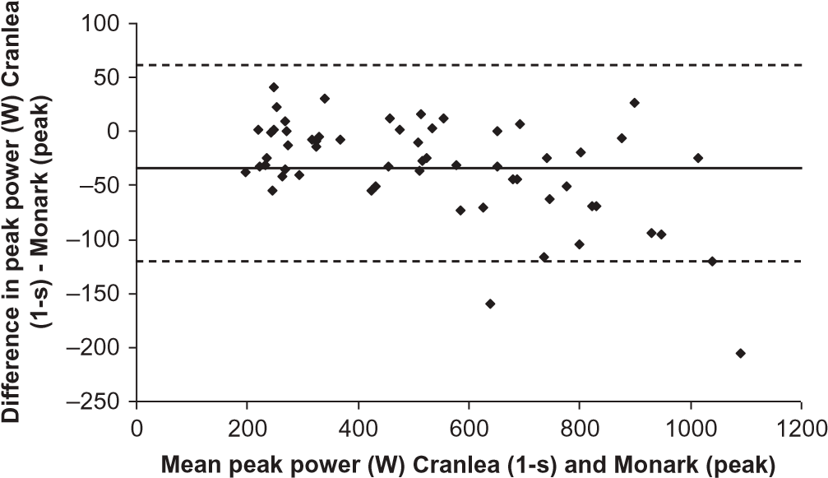
FIGURE 1 Bland and Altman plot with 95% limits of agreement (dashed lines) and mean bias for peak power output between the two measurement devices.

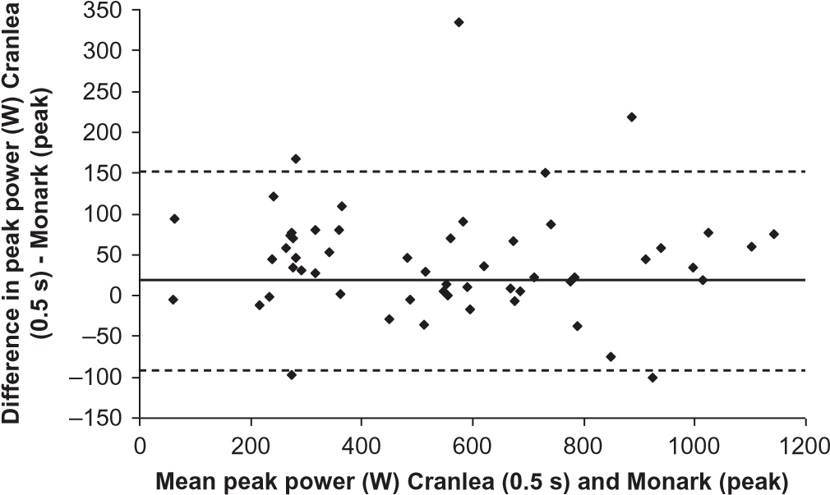
FIGURE 2 Bland and Altman plot with 95% limits of agreement (dashed lines) and mean bias for peak power output between the two measurement devices.

